**0.6 GHz, 26mm (0.05λ)**

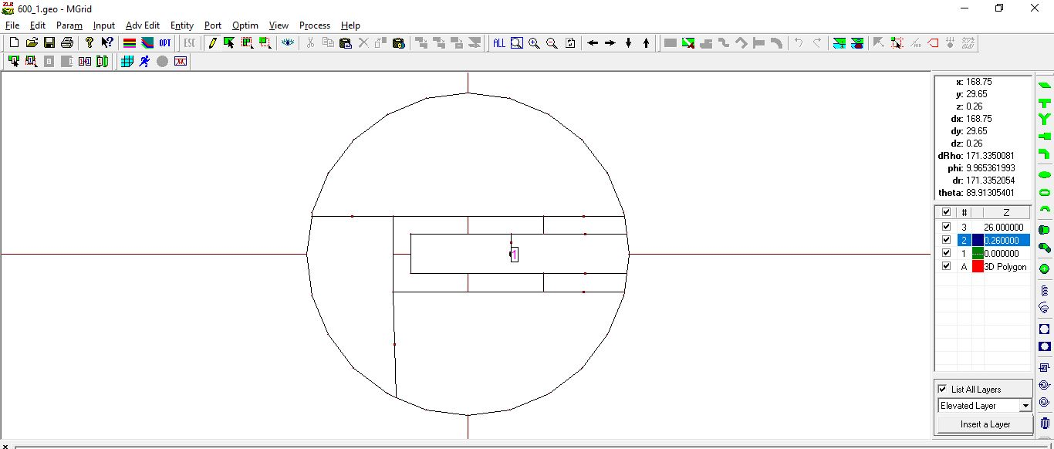

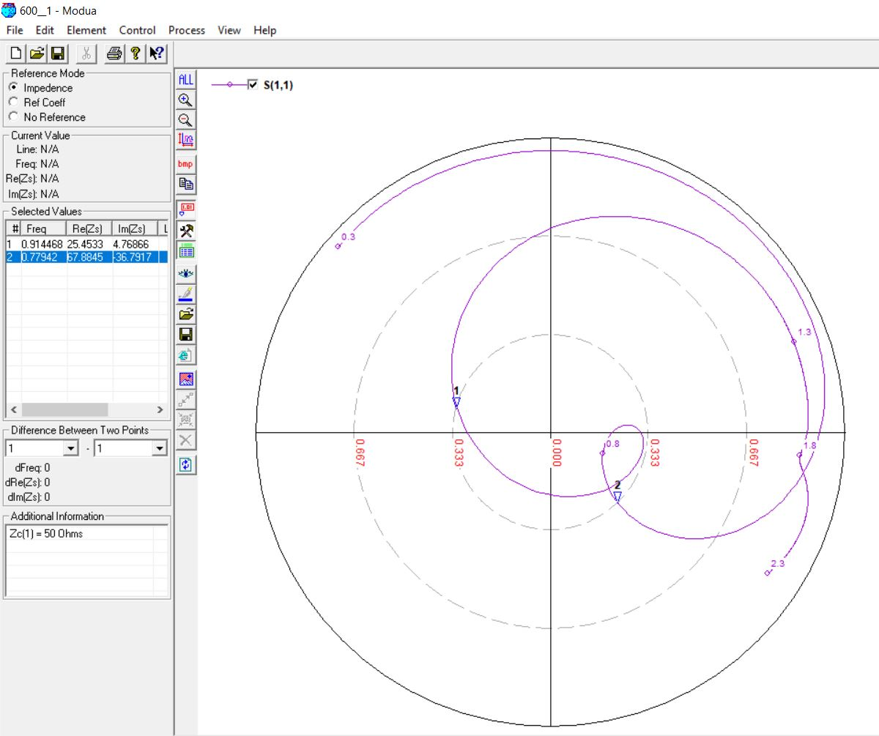

**0.6 GHz, 26mm (0.06λ)**





**0.6 GHz, 26mm (0.07λ)**





**0.6 GHz, 26mm (0.05λ, 0.06λ, 0.07λ) [OPTIMIZED]**

**Original Horizontal Slot Length: 84mm**

**Optimized Horizontal Slot Length: 86mm**

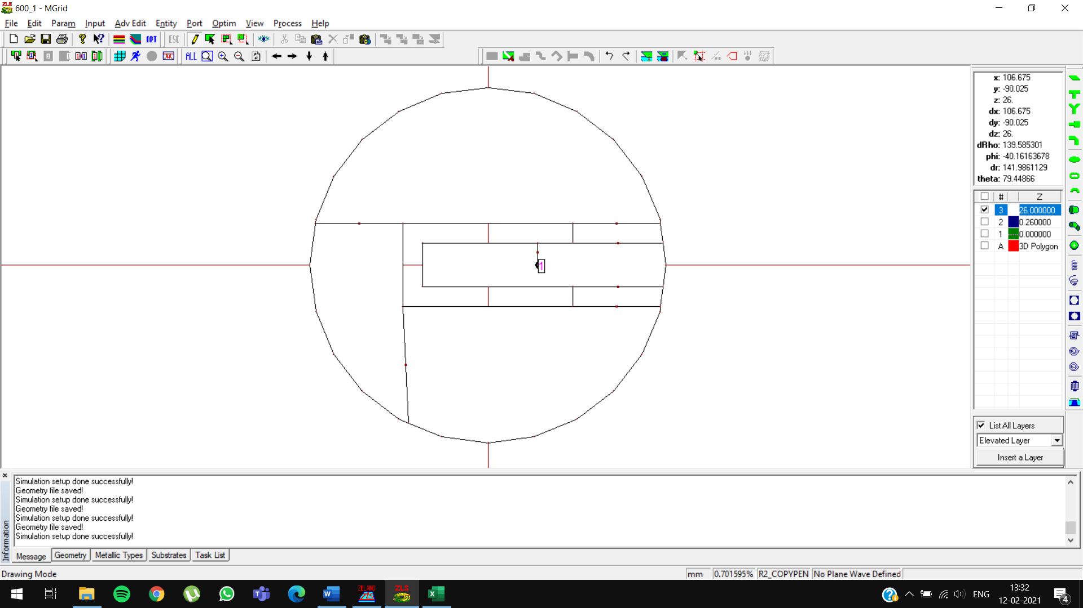

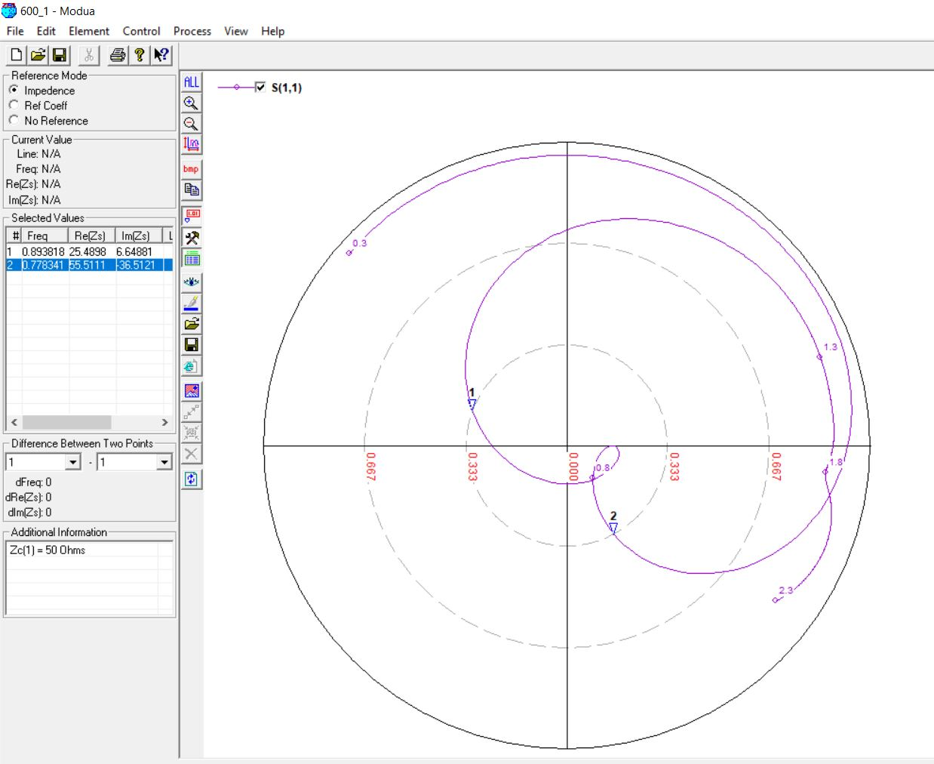

**0.7 GHz, 23mm (0.05λ)**

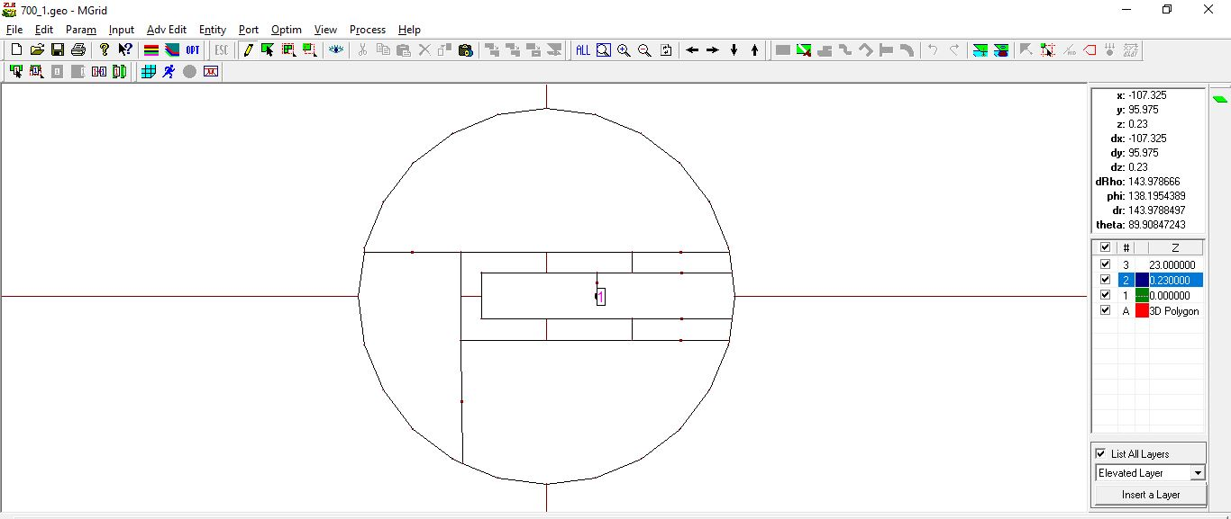

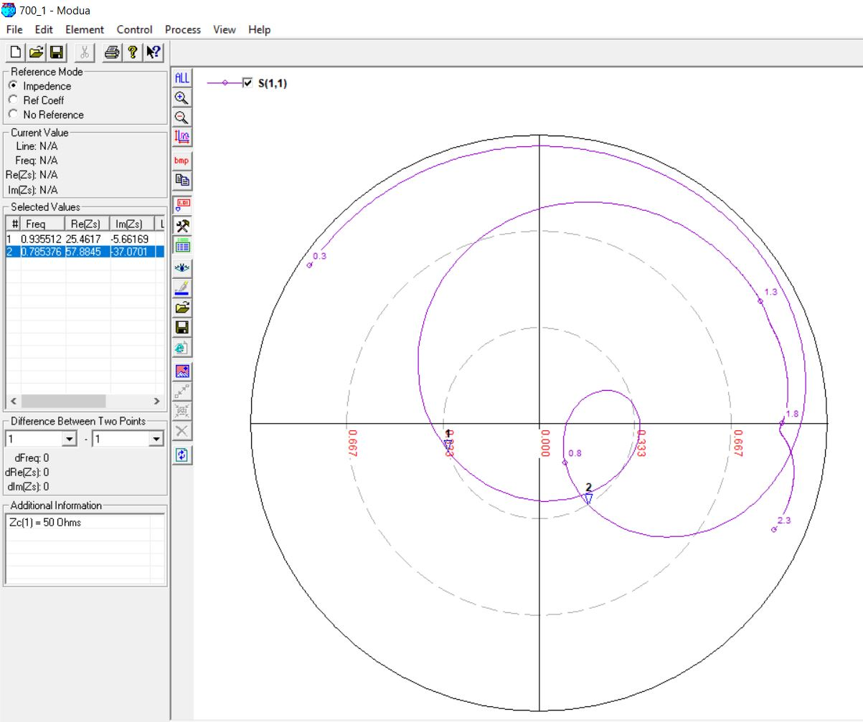

**0.7 GHz, 22mm (0.06λ)**

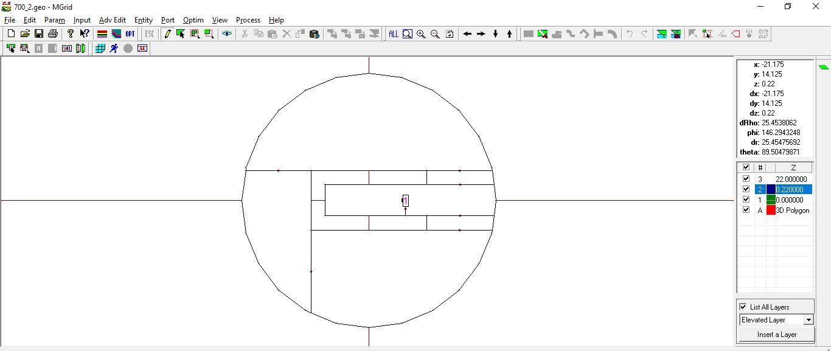

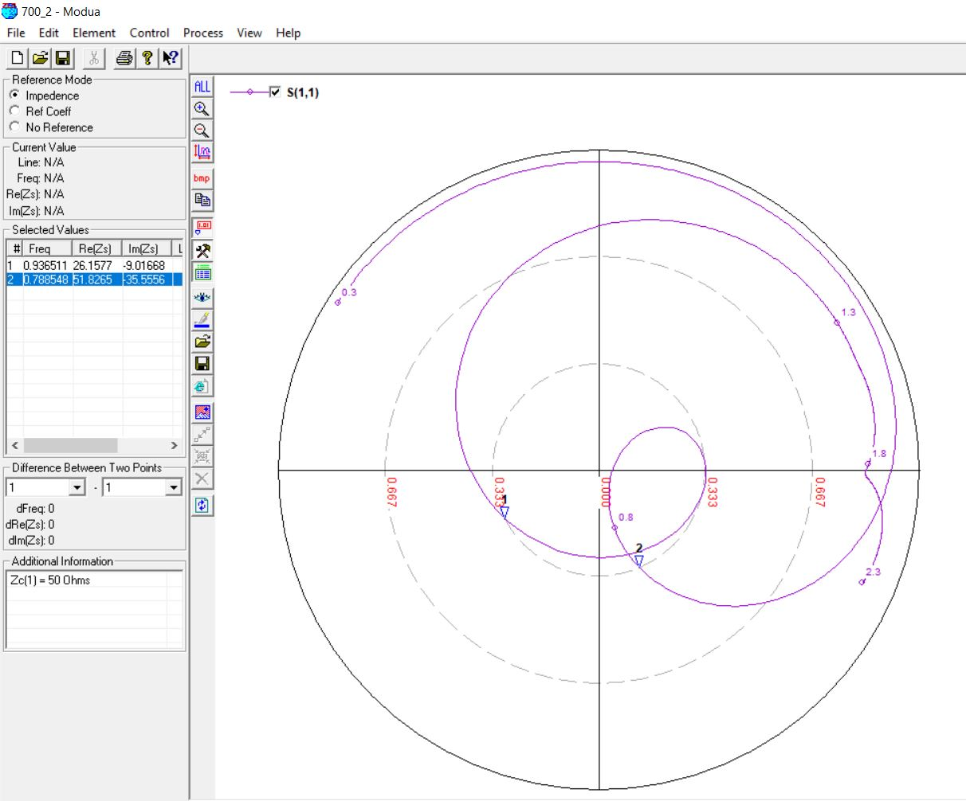

**0.7 GHz, 22mm (0.07λ)**

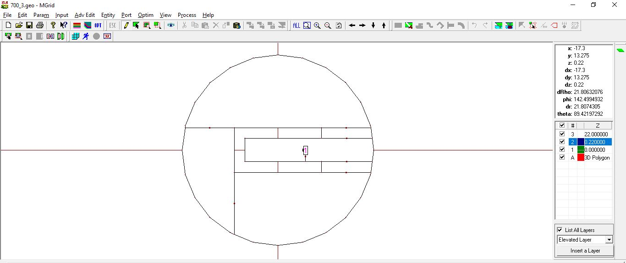

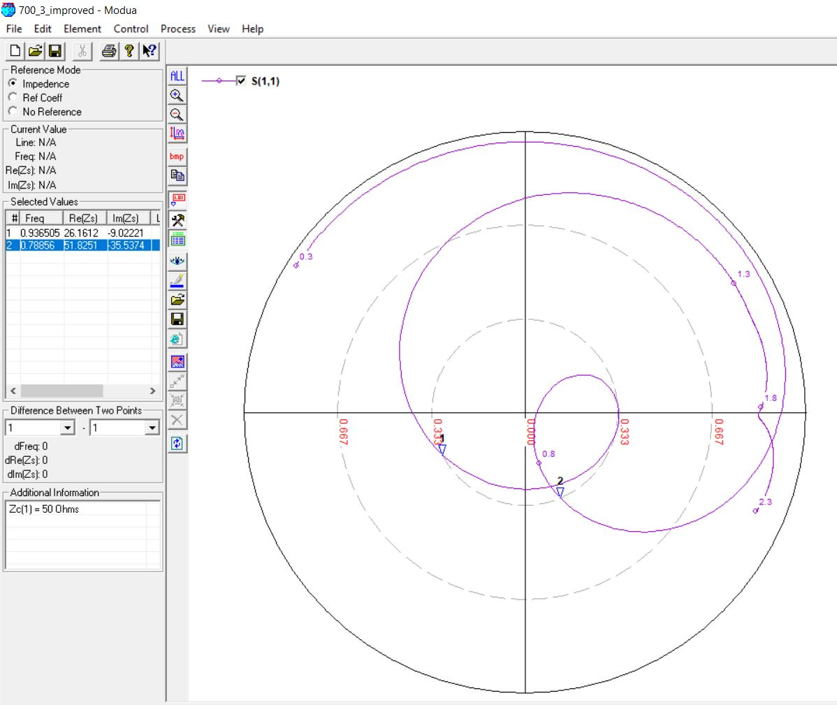

**0.7 GHz, 23mm (0.05λ, 0.06λ, 0.07λ) [OPTIMIZED]**

**Original Feed Position: 25**

**Optimized Feed Position: 27**

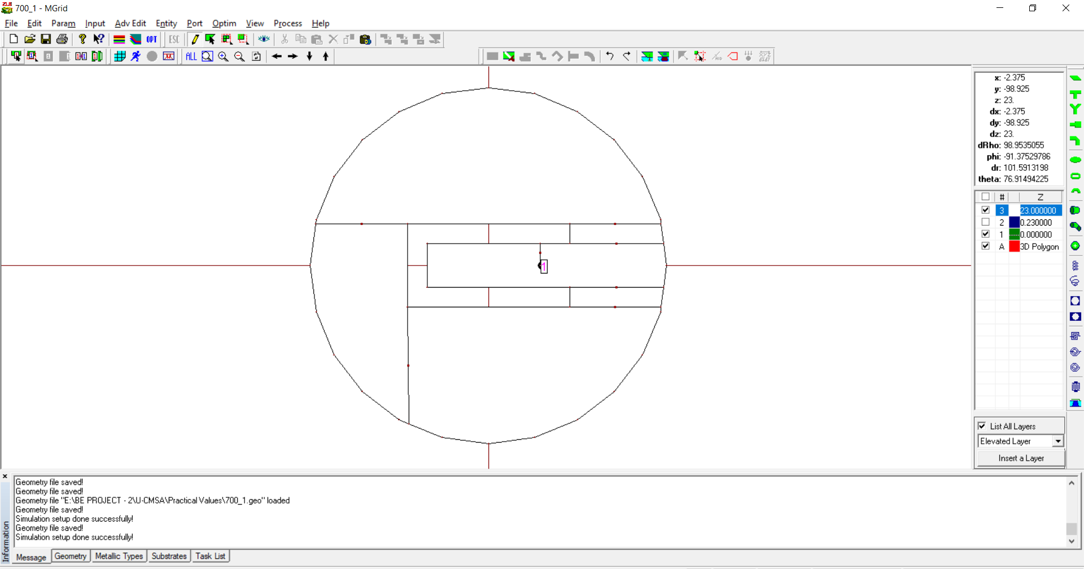

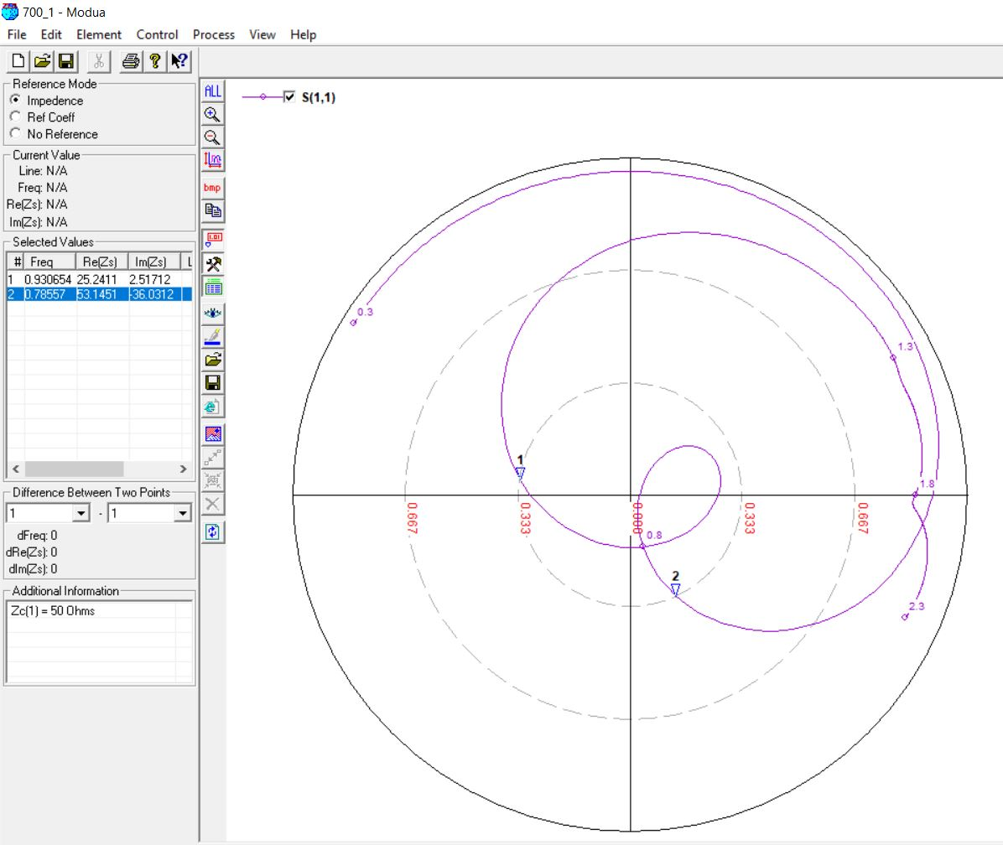

**0.9 GHz, 21 mm (0.05λ)**

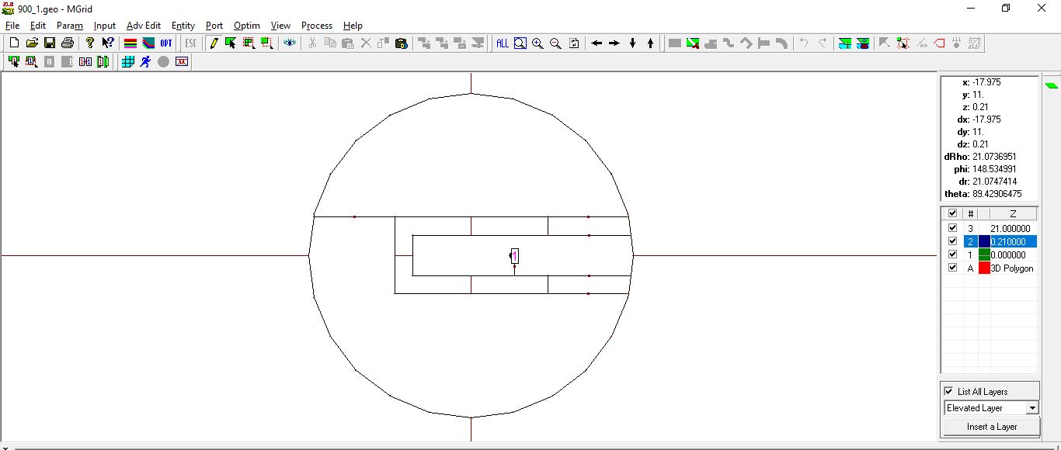

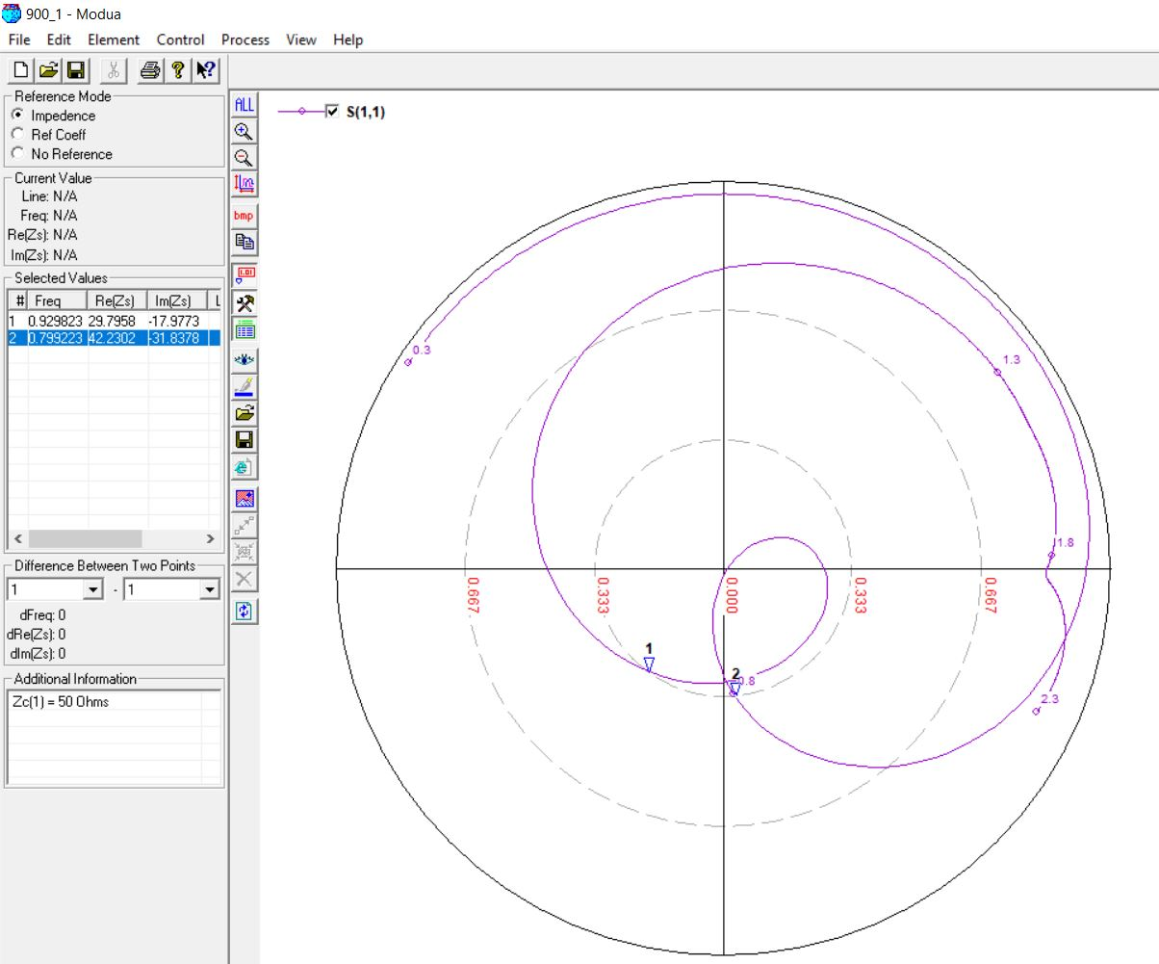

**0.9 GHz, 16 mm (0.06λ)**

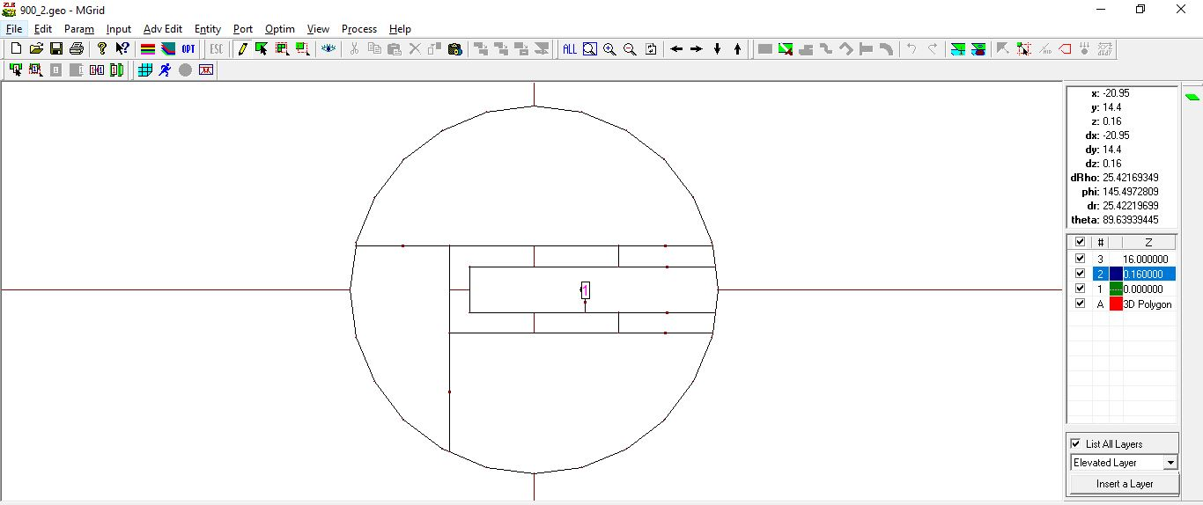

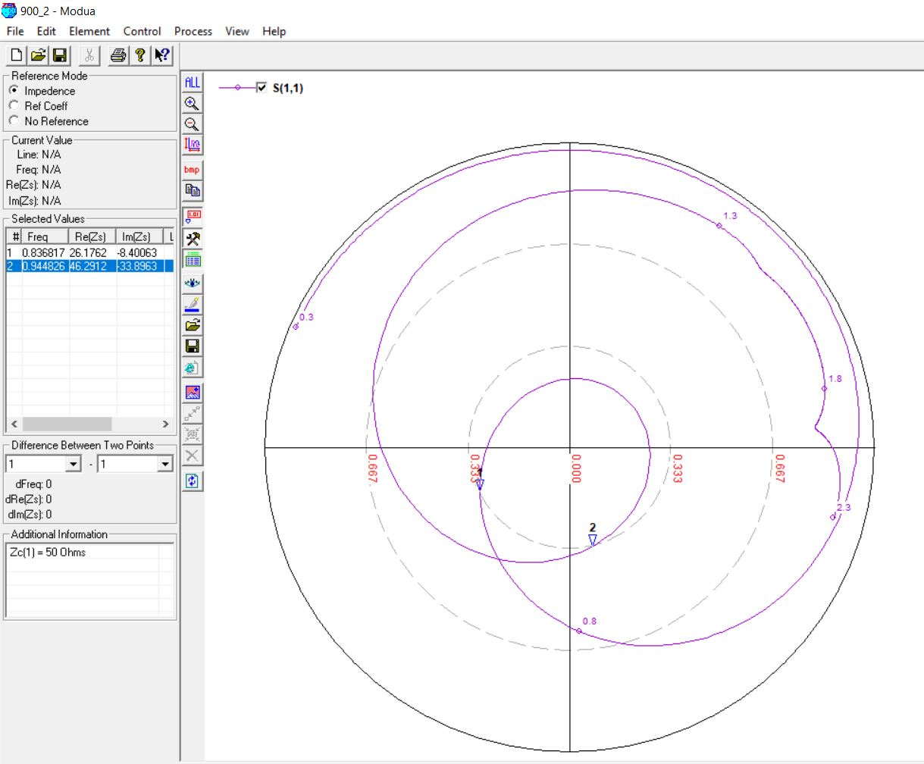

**0.9 GHz, 24 mm (0.07λ)**

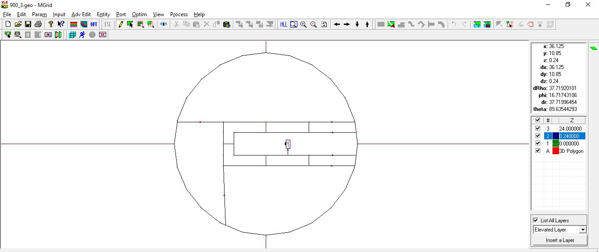

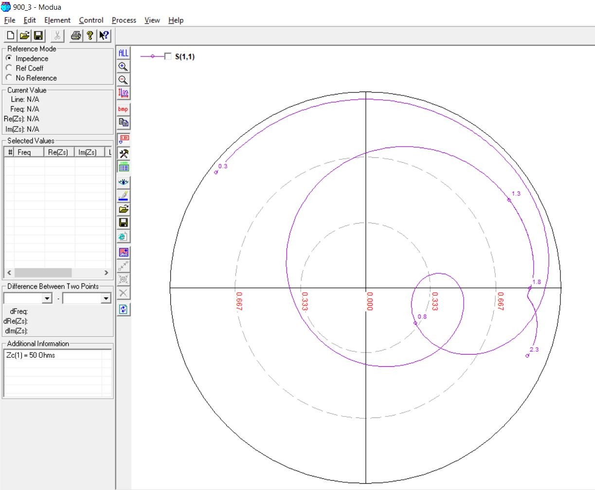

**0.9 GHz, 24 mm (0.07λ) [OPTIMIZED]**

**Original Horizontal Slot Length: 79mm Feed Position: 20**

**Optimized Horizontal Slot Length: 82mm Feed Position: 25**

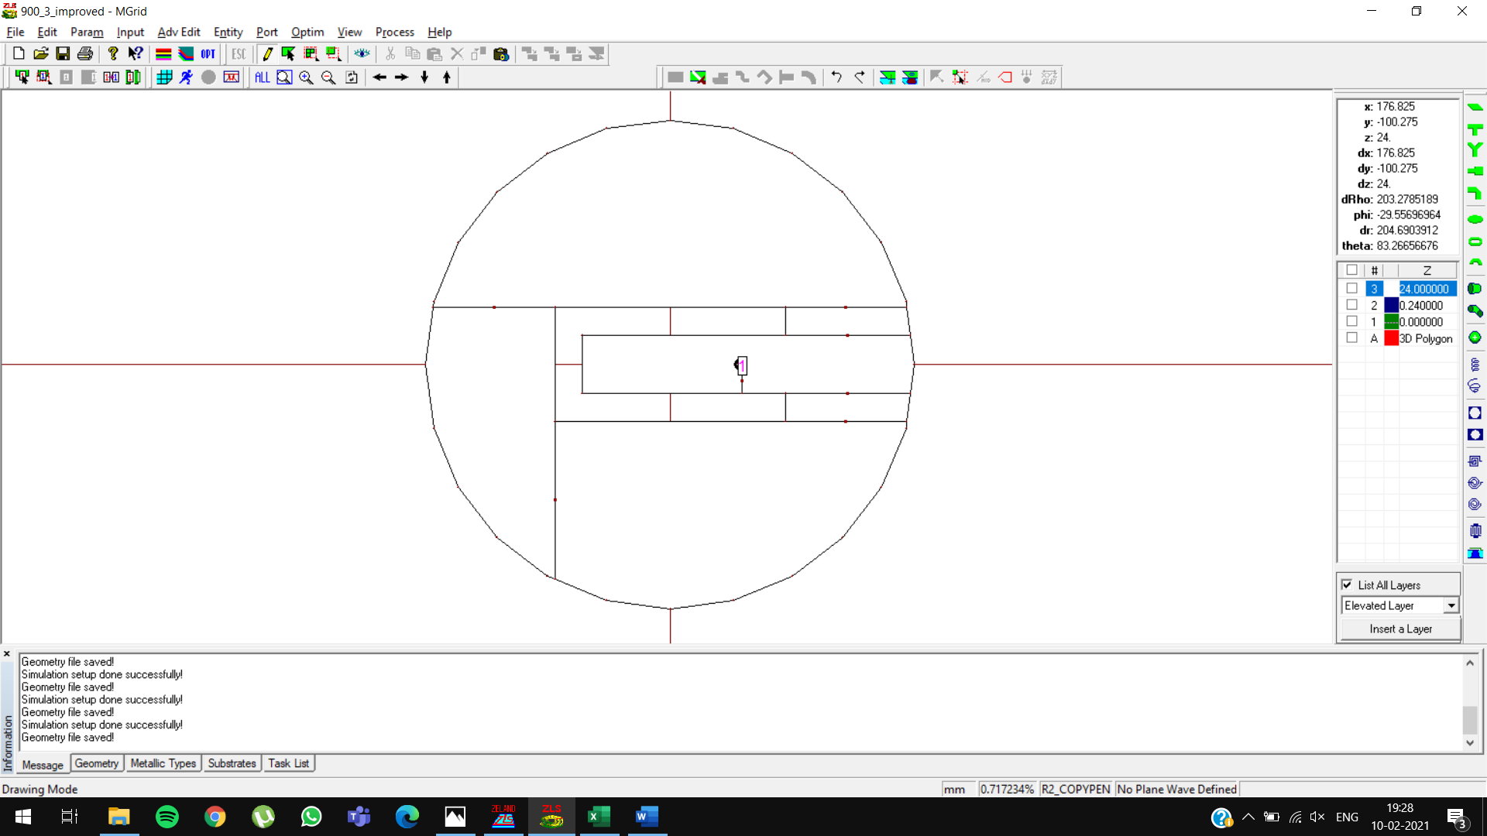

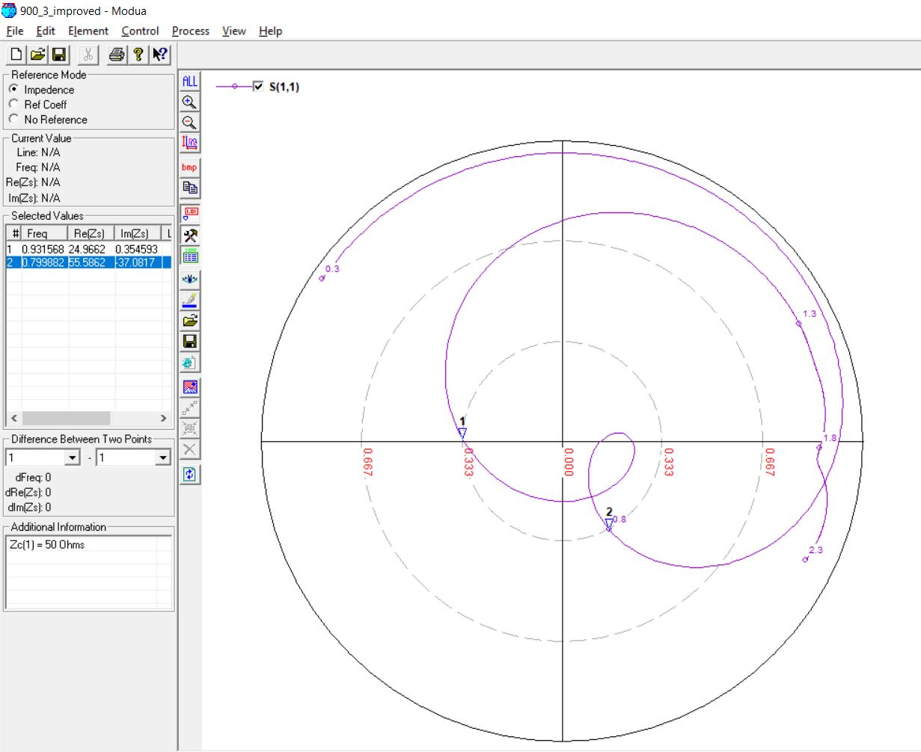

**1.5 GHz, 10 mm (0.05λ)**

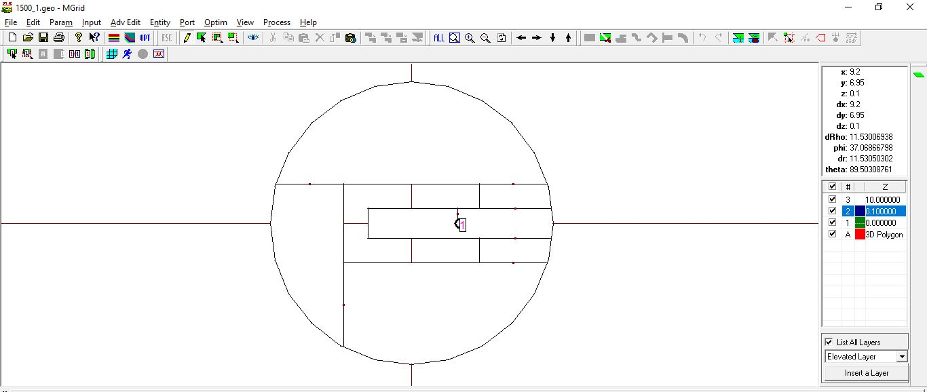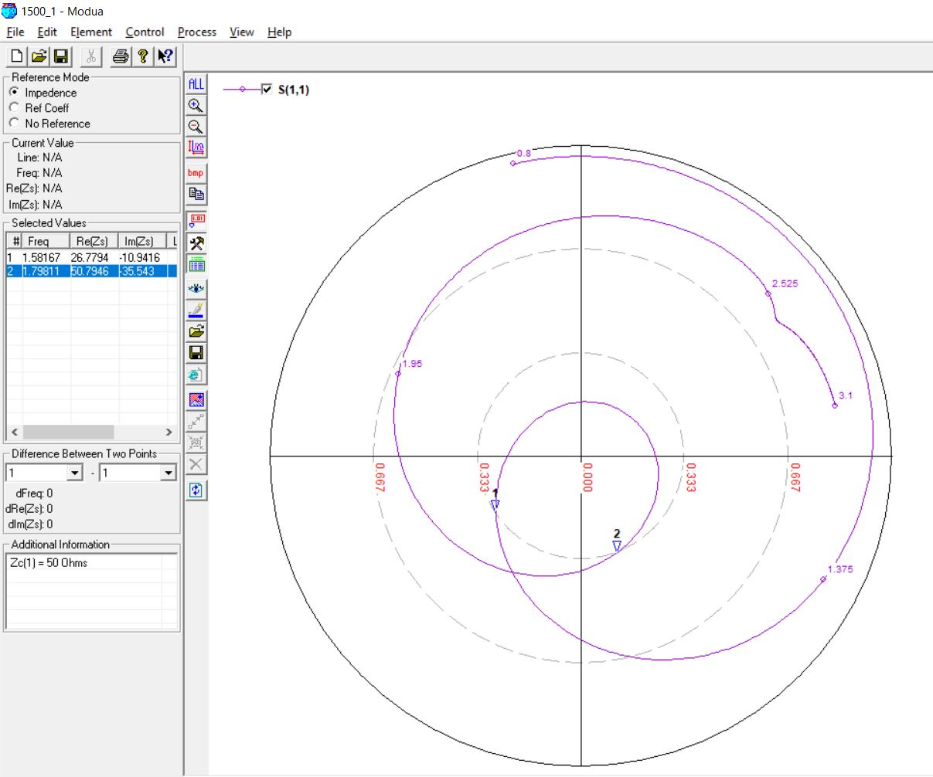

**1.5 GHz, 12 mm (0.06λ)**

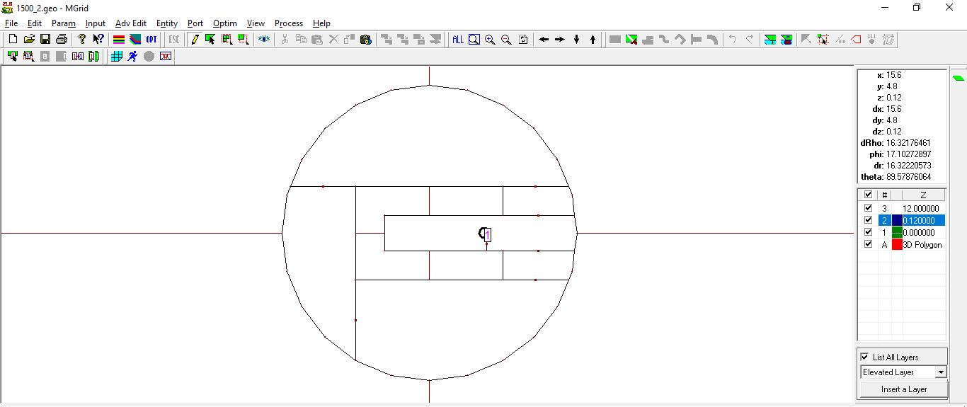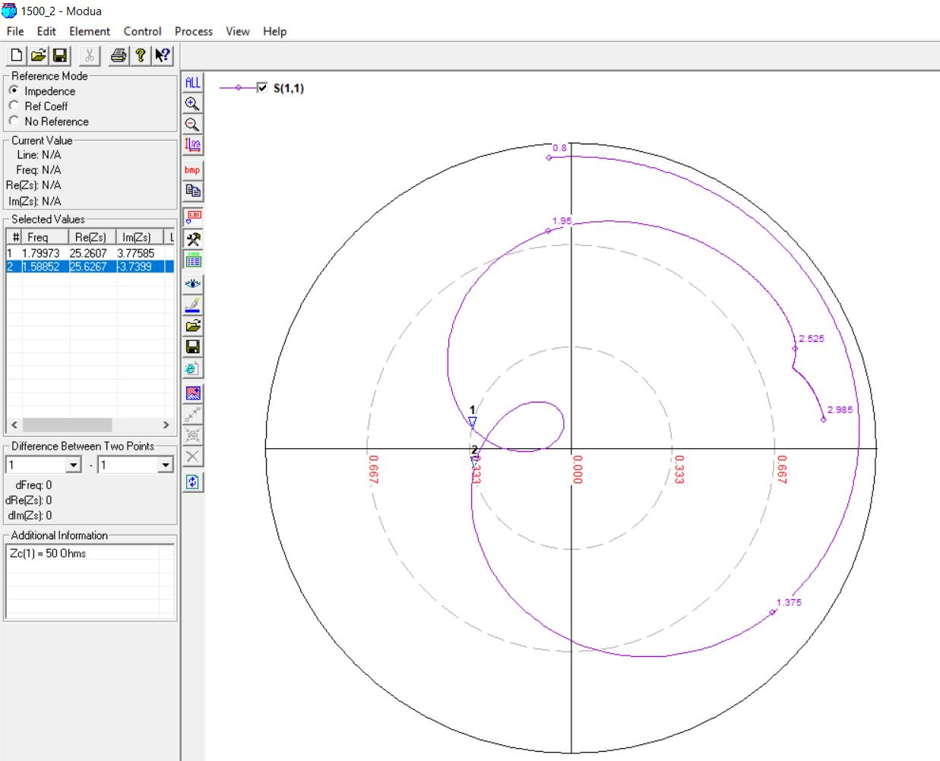

**1.5 GHz, 14 mm (0.07λ)**

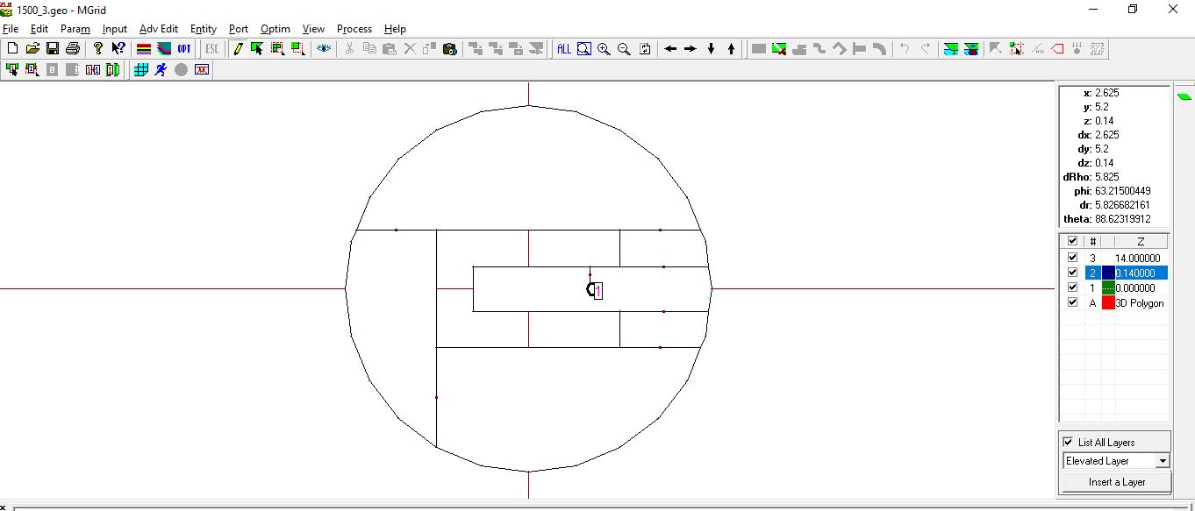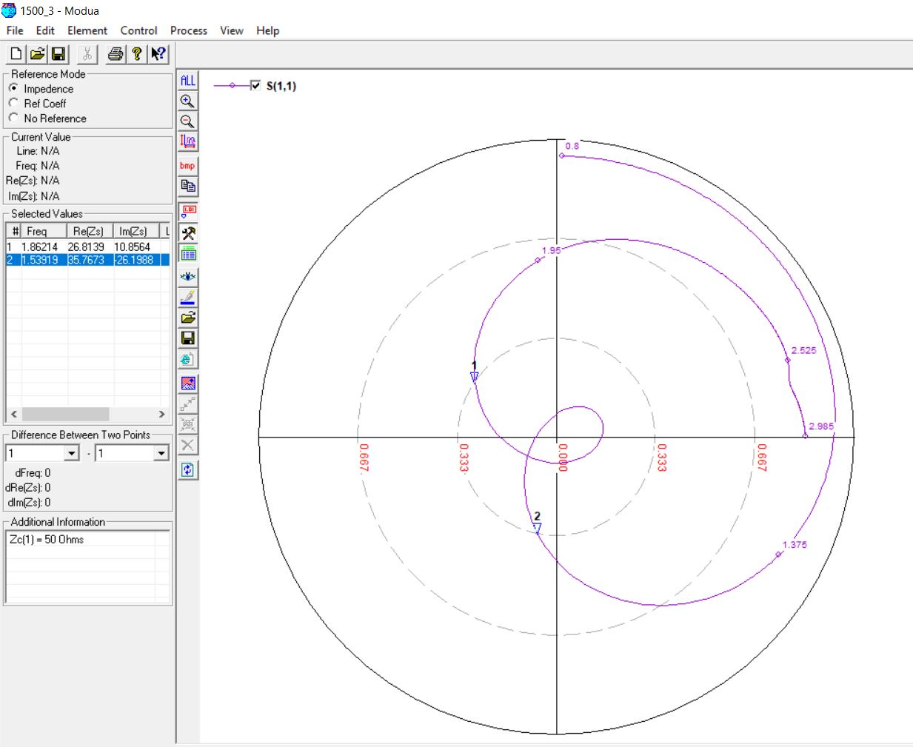

**2.1 GHz, 11 mm (0.05λ)**

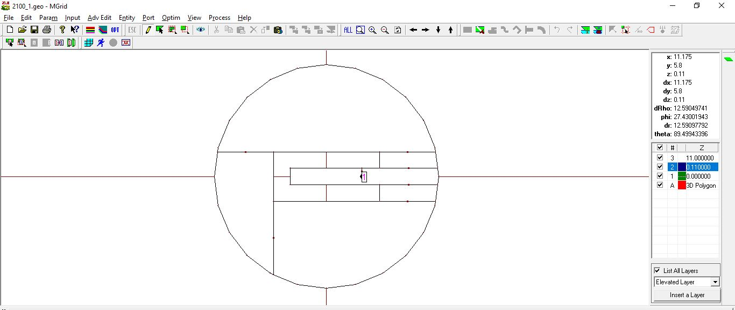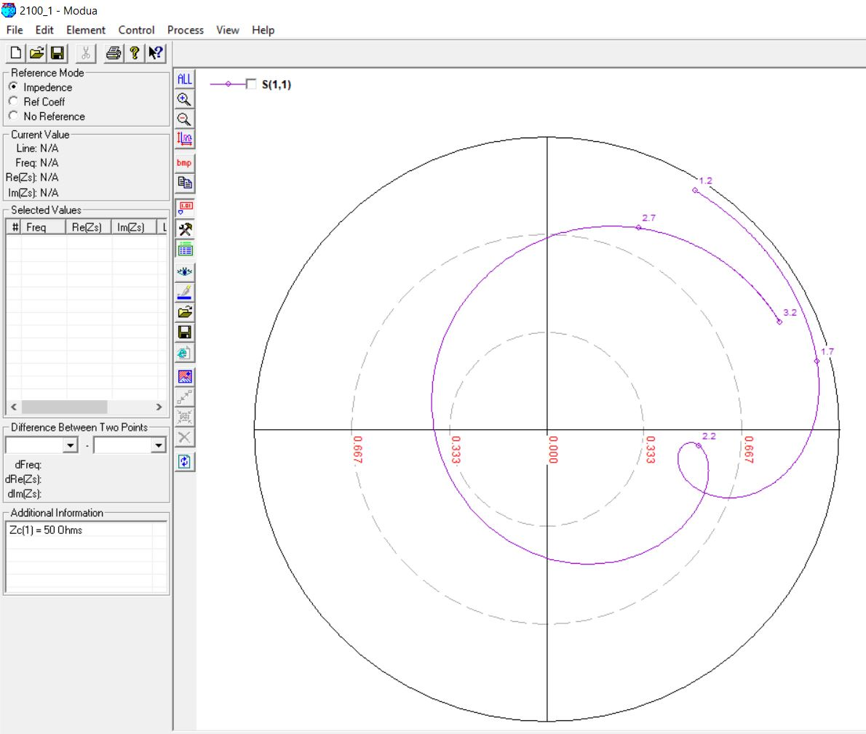

**2.1 GHz, 11 mm (0.05λ) [OPTIMIZED]**

**Original Feed Position: 11**

**Optimized Feed Position: 13**

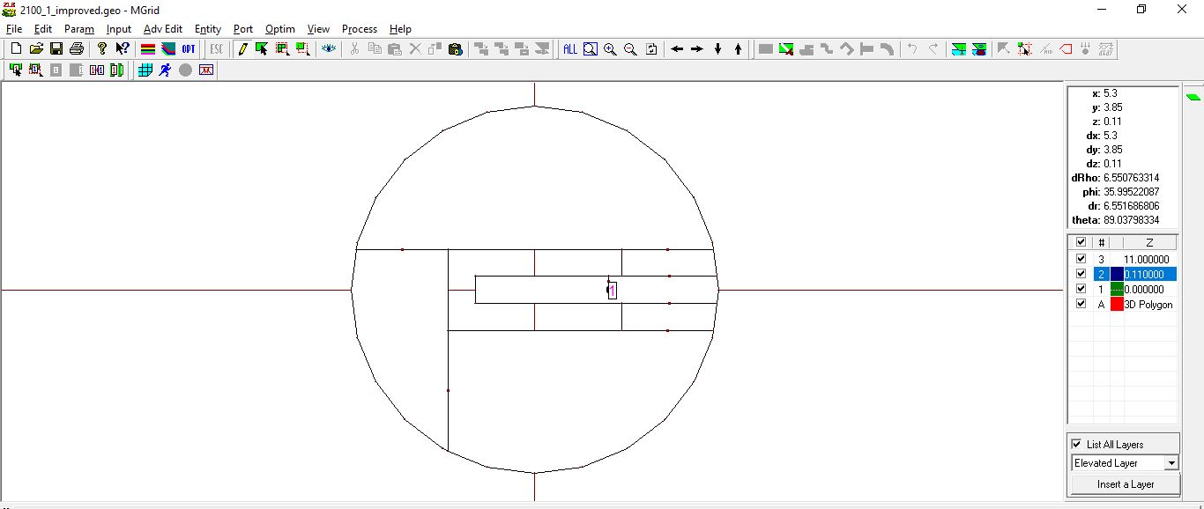

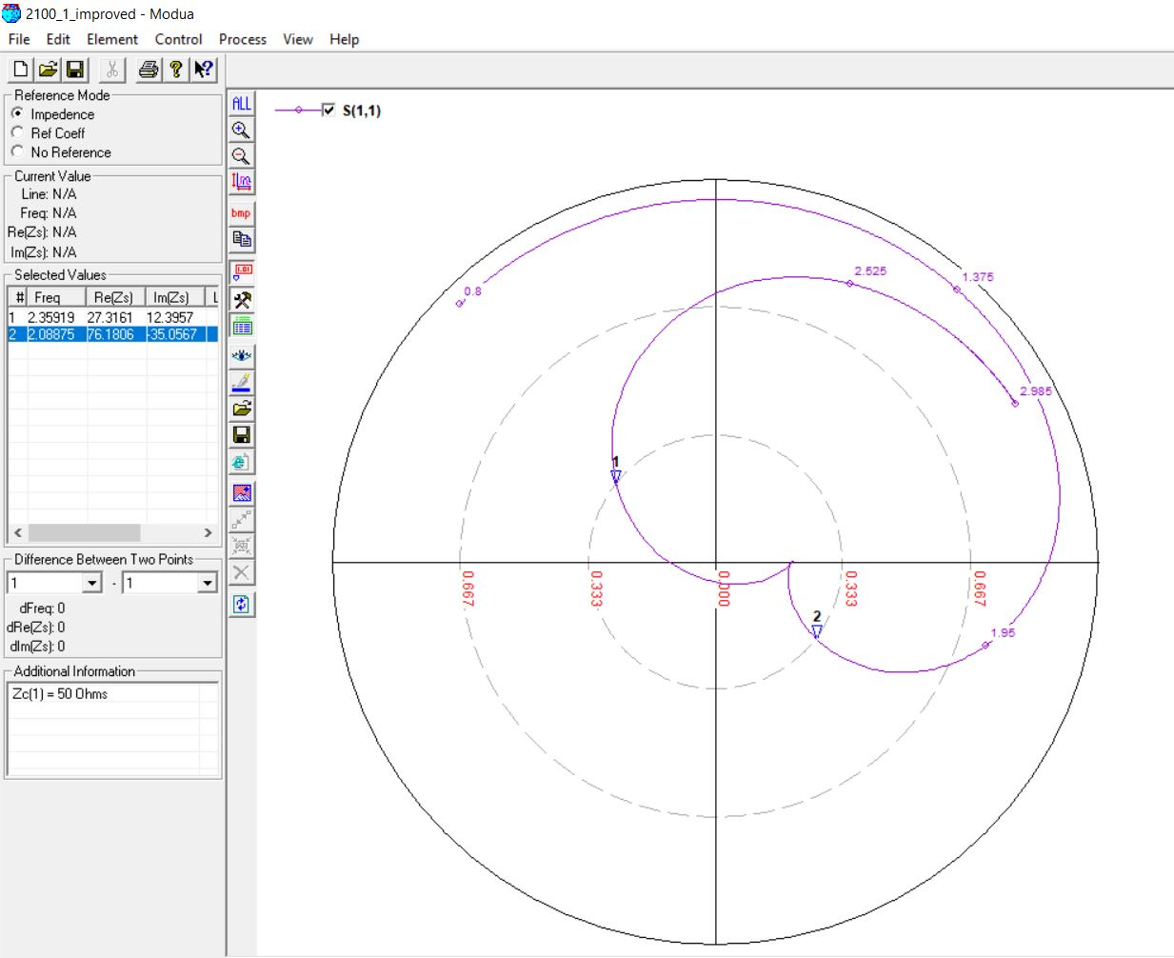

**2.1 GHz, 10 mm (0.06λ)**

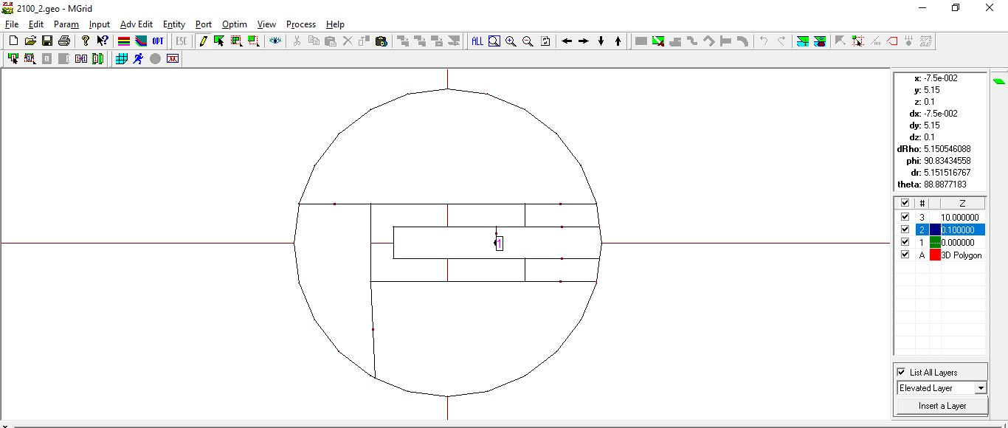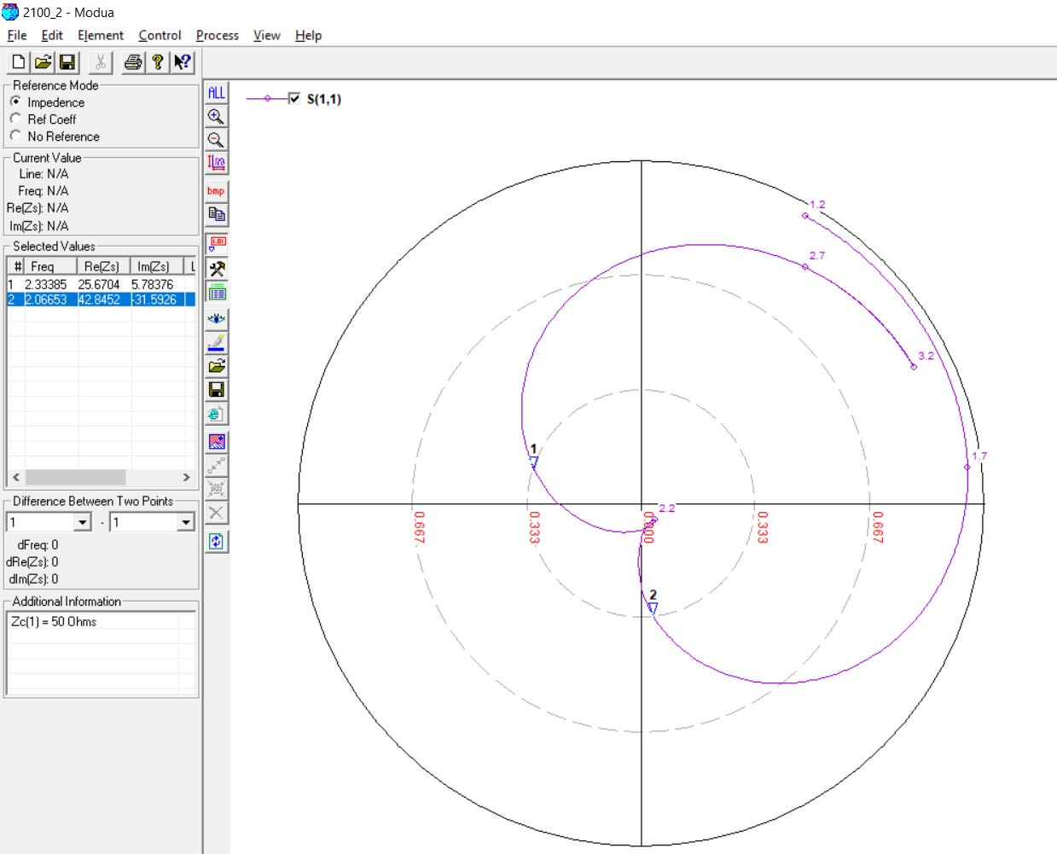

**2.1 GHz, 12 mm (0.07λ)**

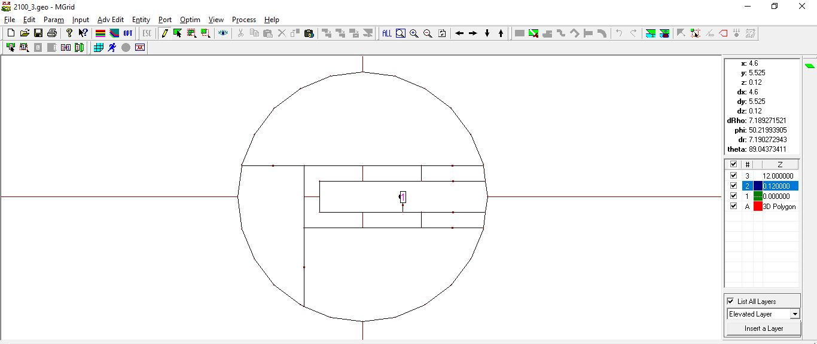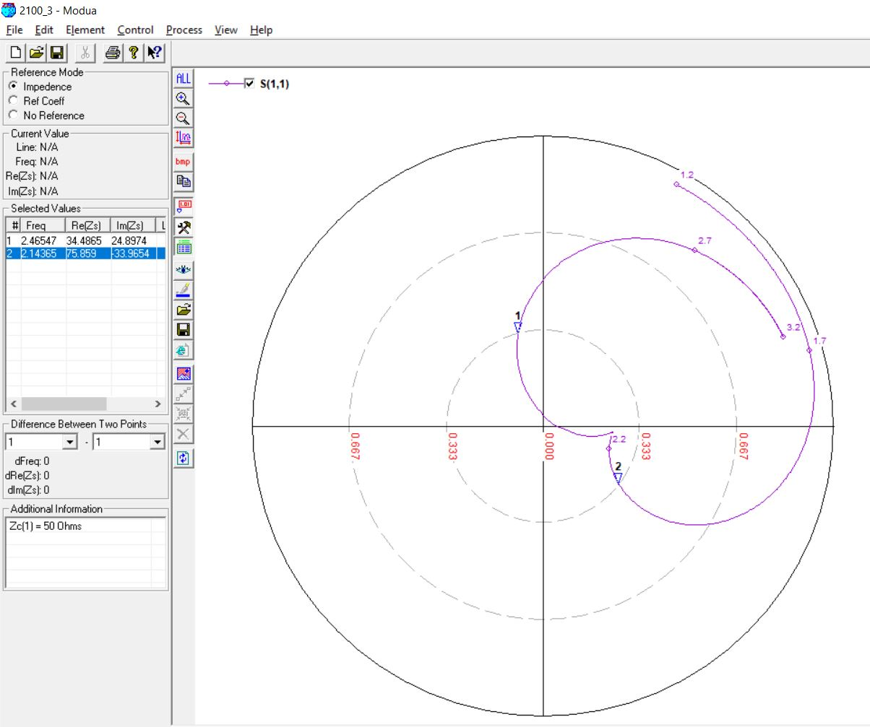

**2.7 GHz, 7 mm (0.05λ)**

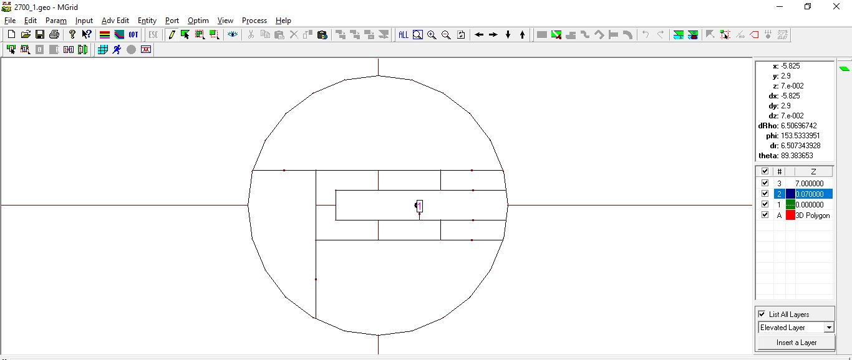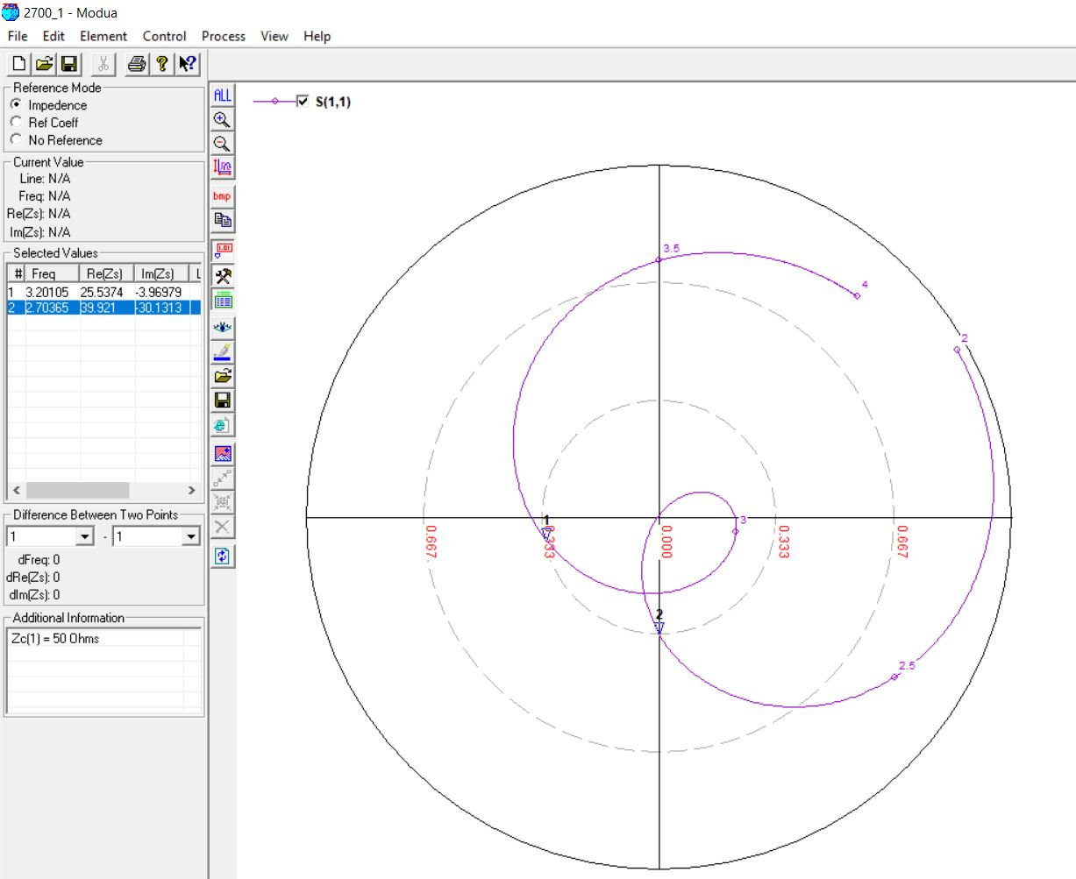

**2.7 GHz, 8 mm (0.06λ)**

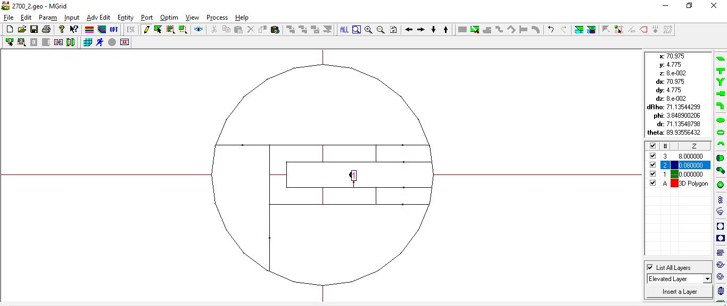

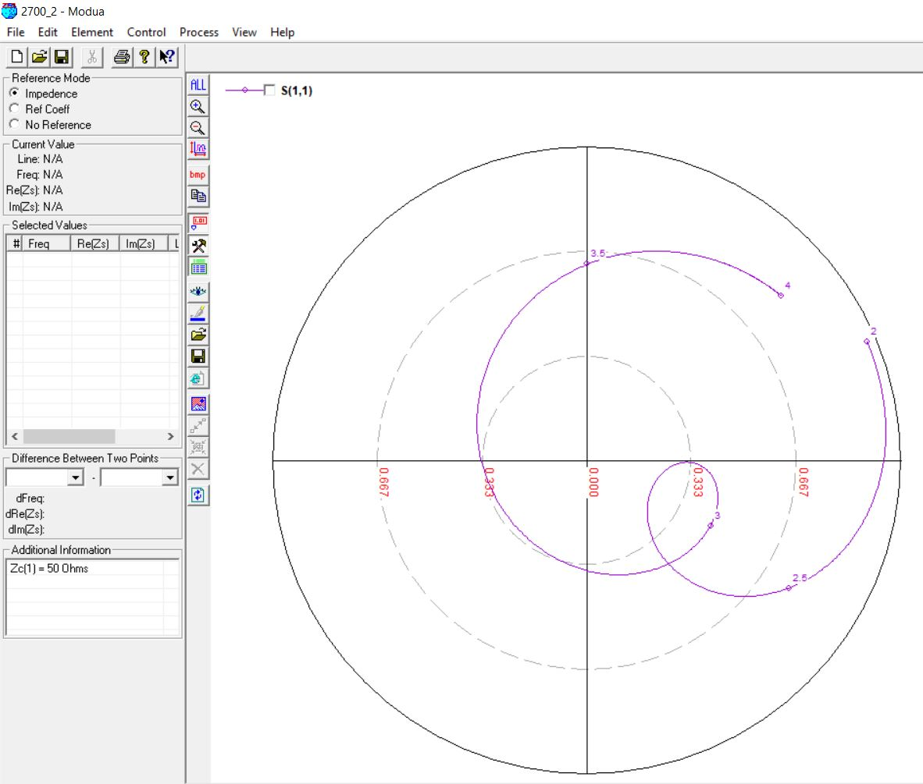

**2.7 GHz, 8 mm (0.06λ) [OPTIMIZED]**

**Original Feed Position: 7**

**Optimized Feed Position: 8**

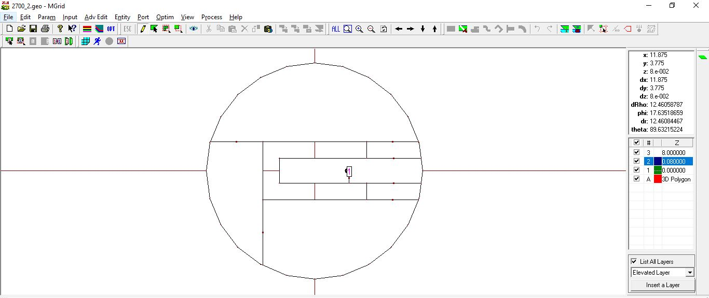

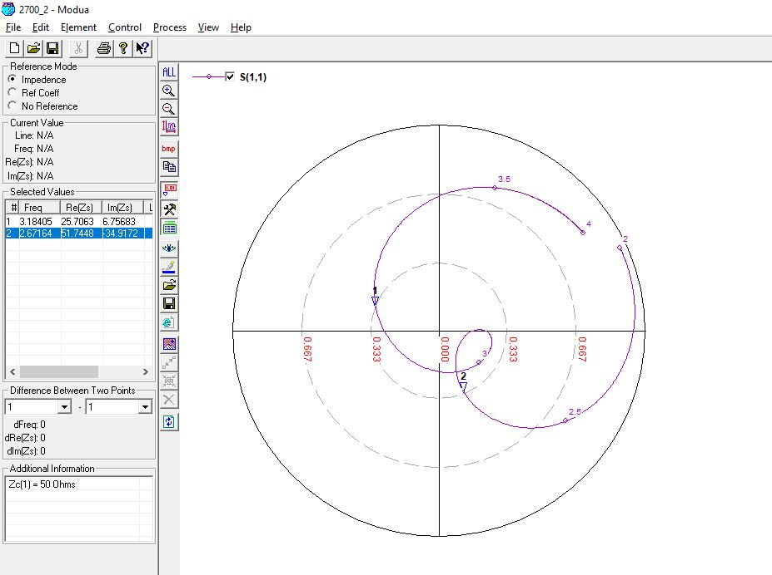

**2.7 GHz, 9 mm (0.07λ)**

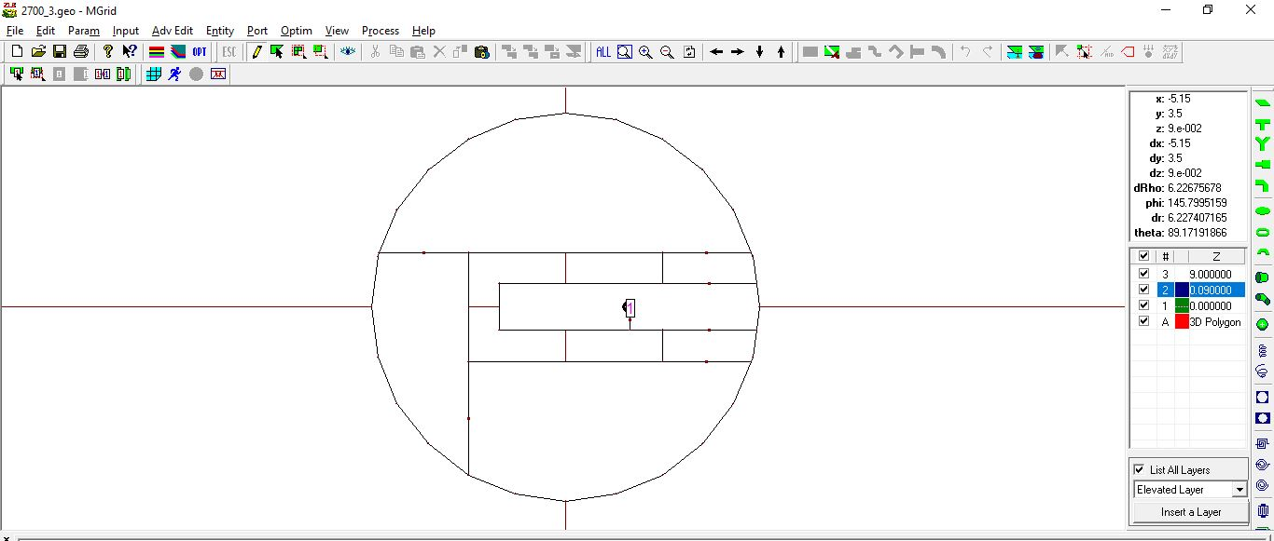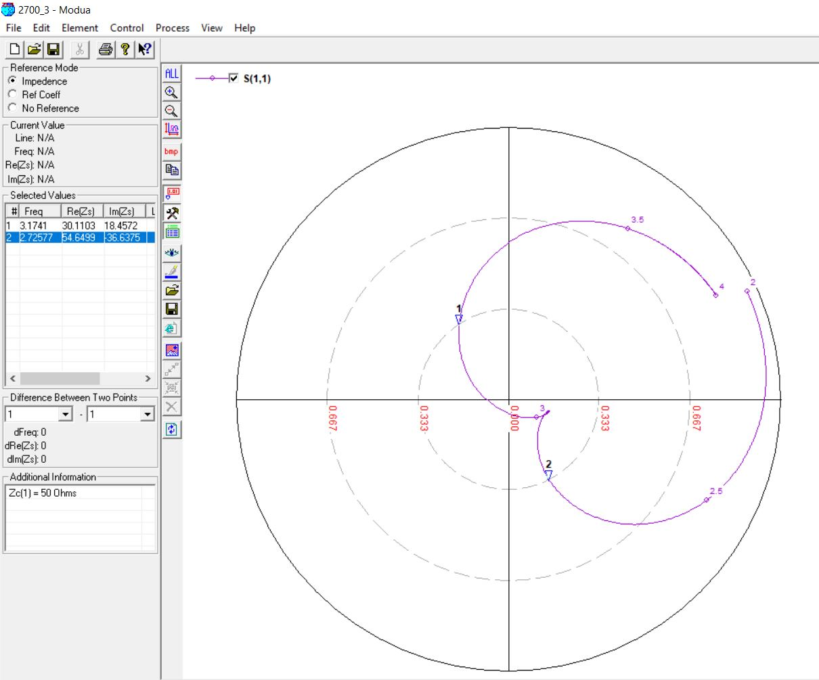

**3.3 GHz, 4 mm (0.05λ)**

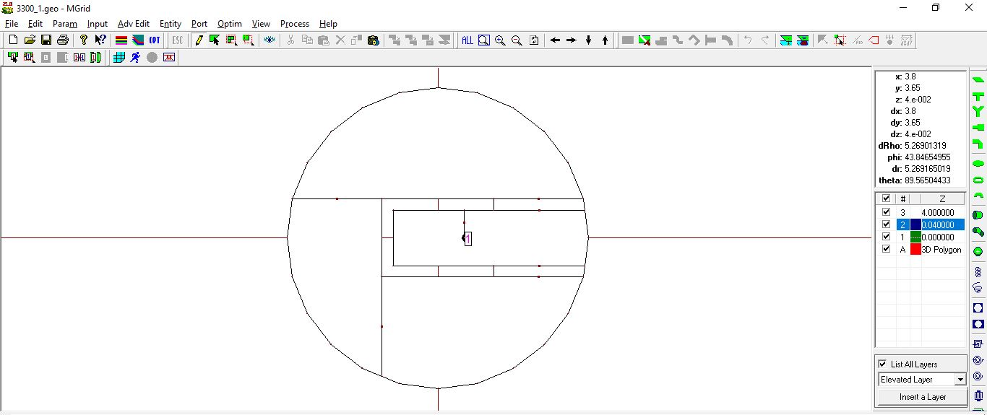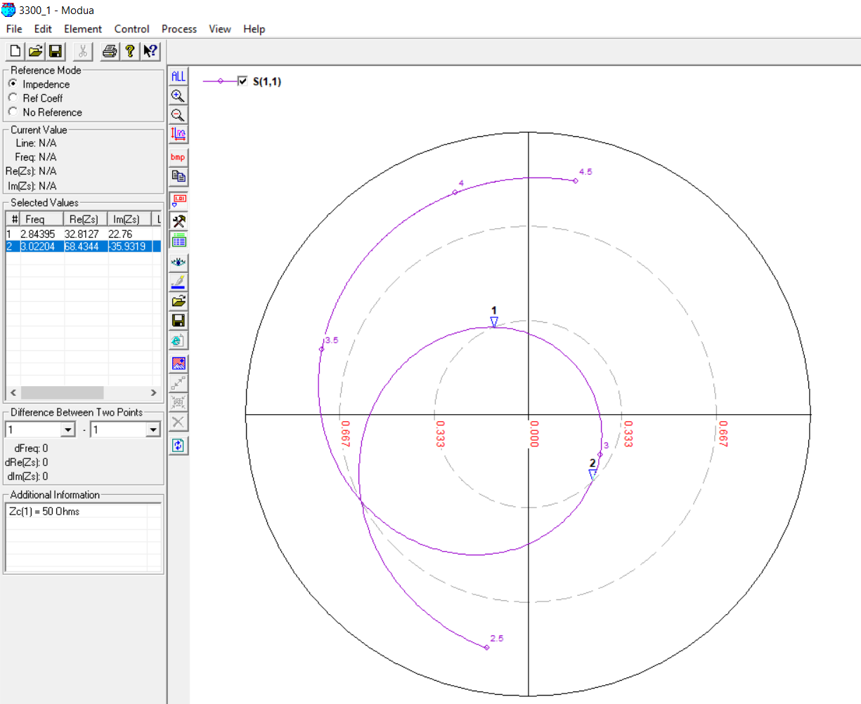

**3.3 GHz, 6 mm (0.06λ)**

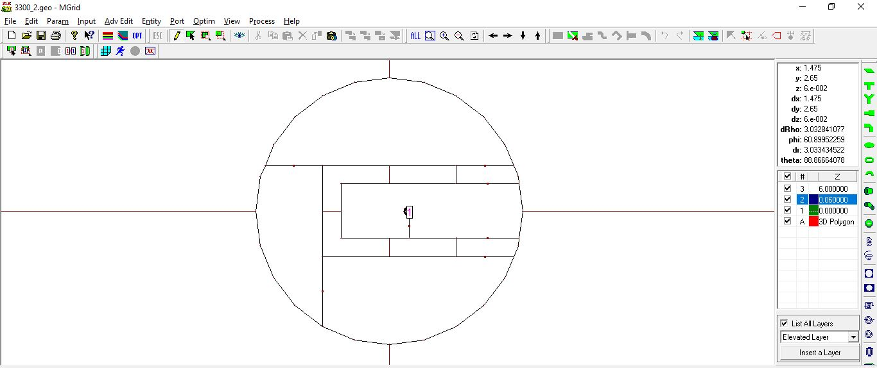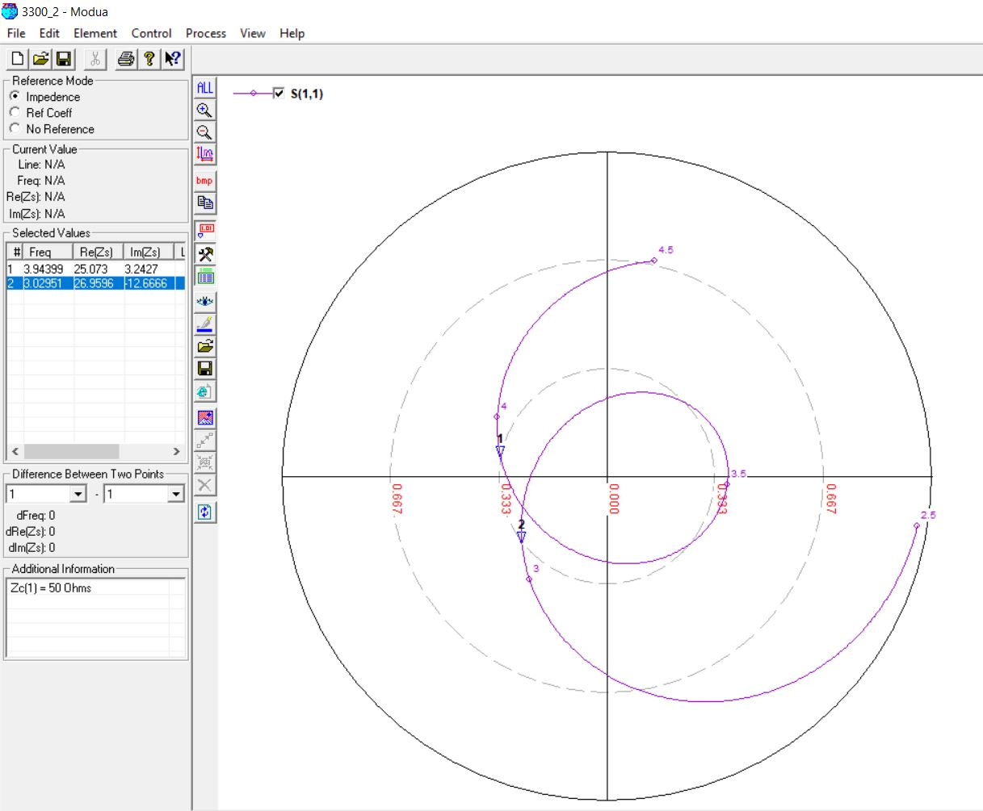

**3.3 GHz, 6 mm (0.07λ)**

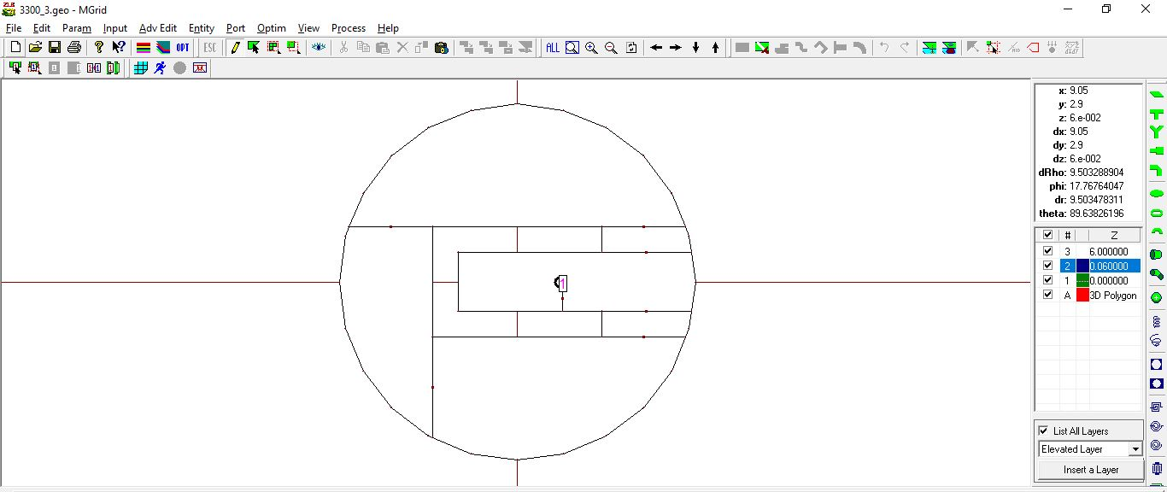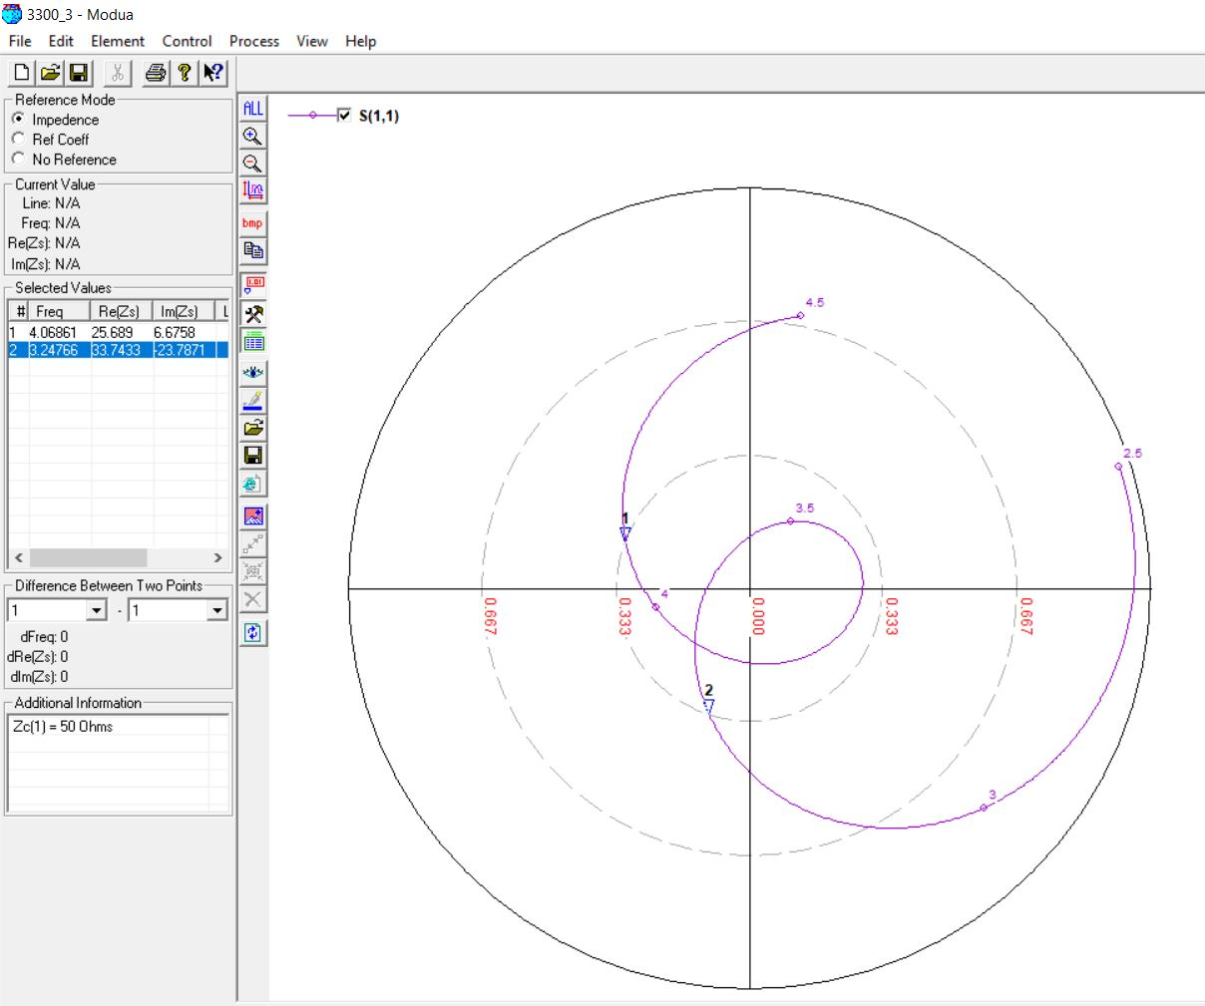

**3.9 GHz, 4 mm (0.05λ)**

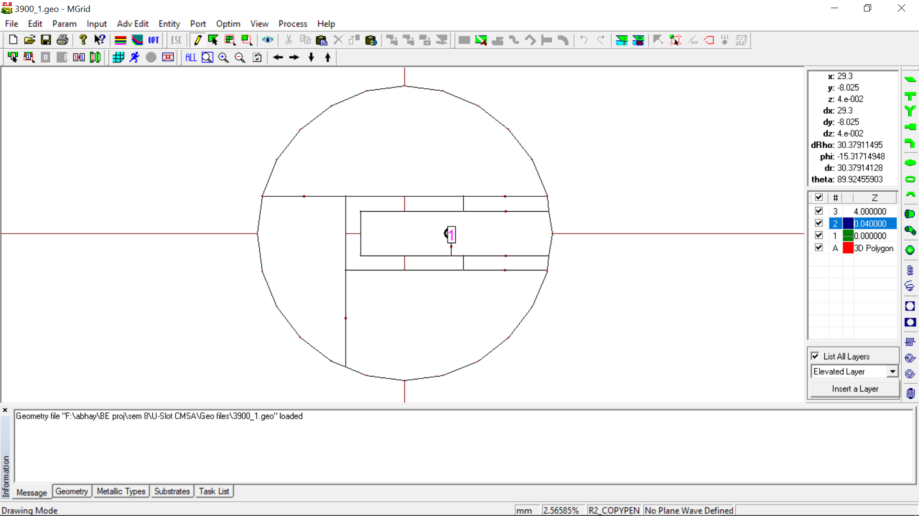

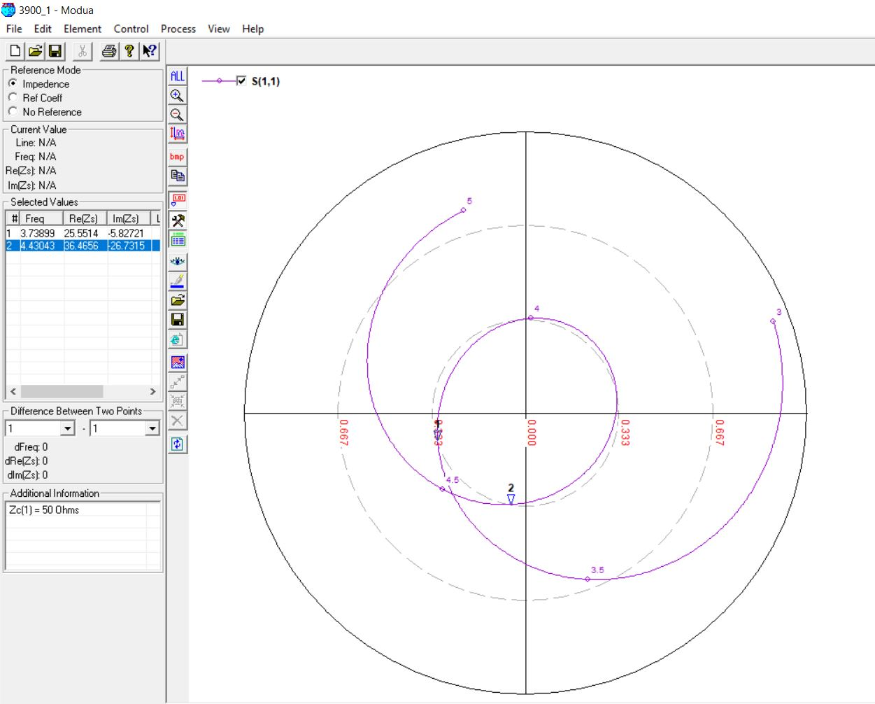

**3.9 GHz, 4 mm (0.06λ)**

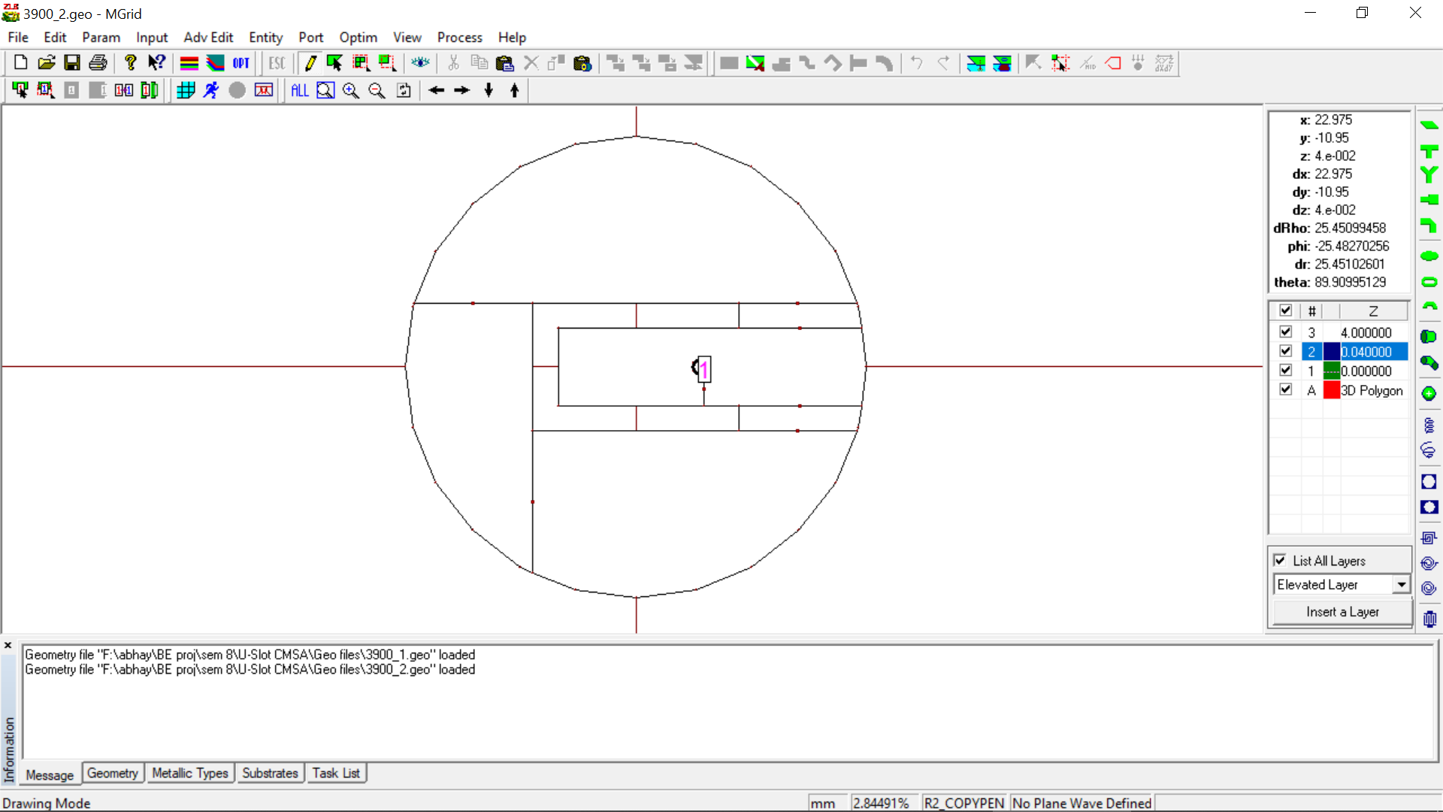

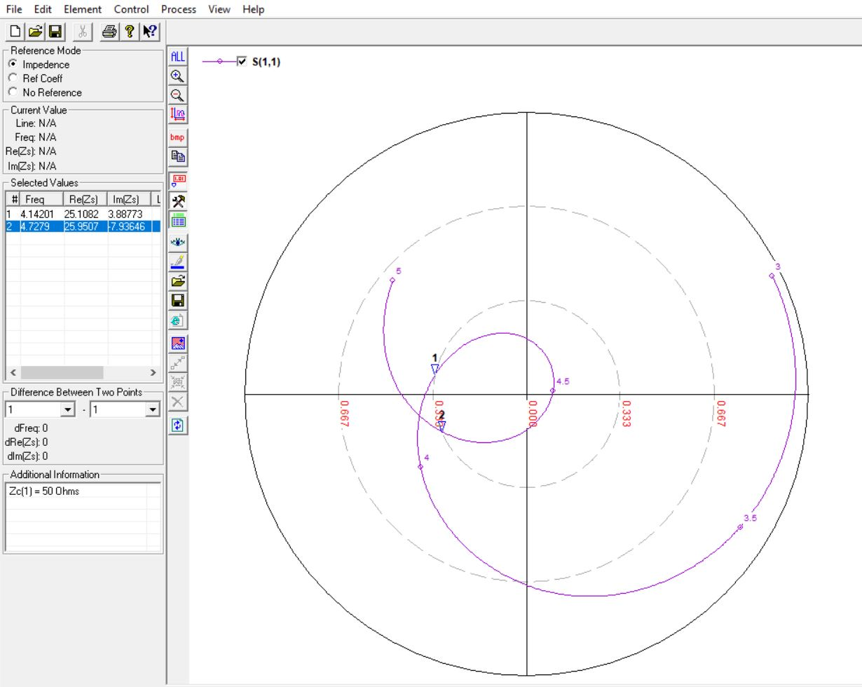

**3.9 GHz, 4 mm (0.07λ)**

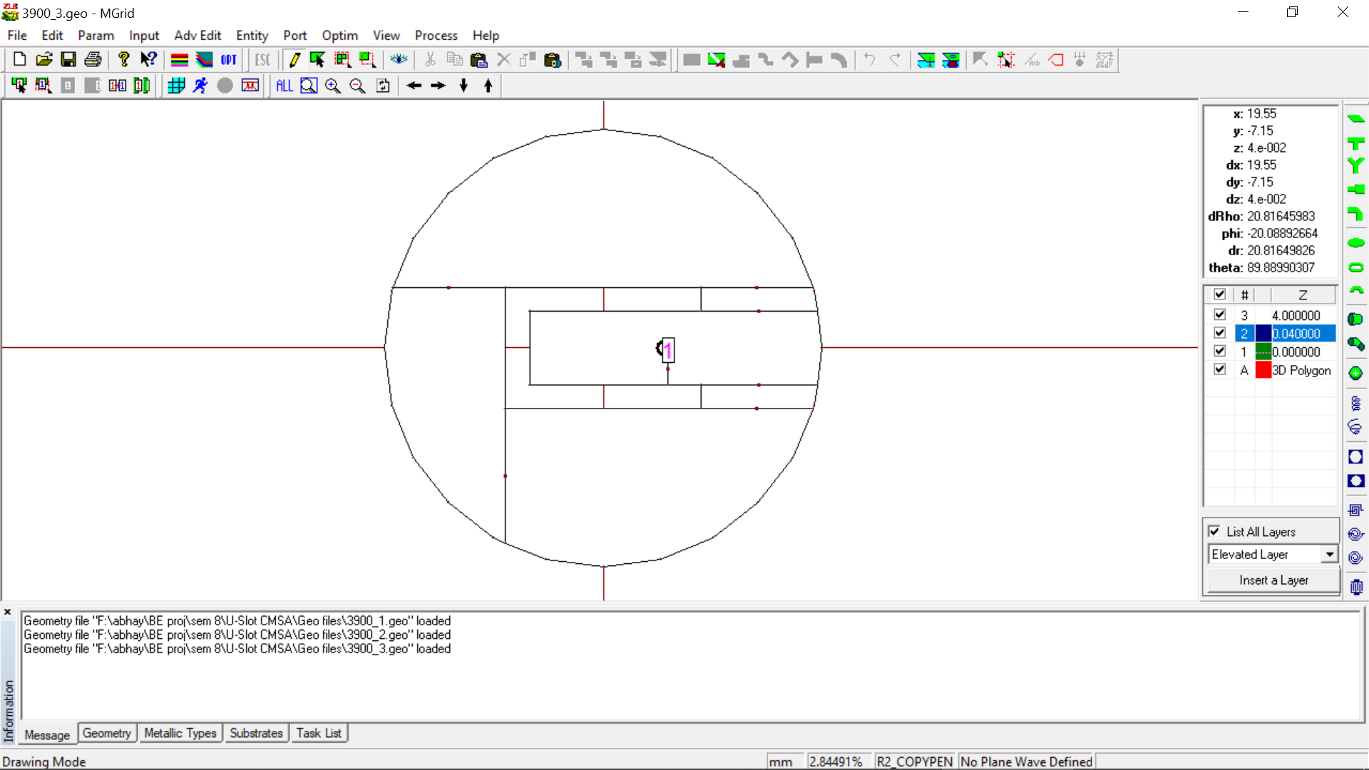

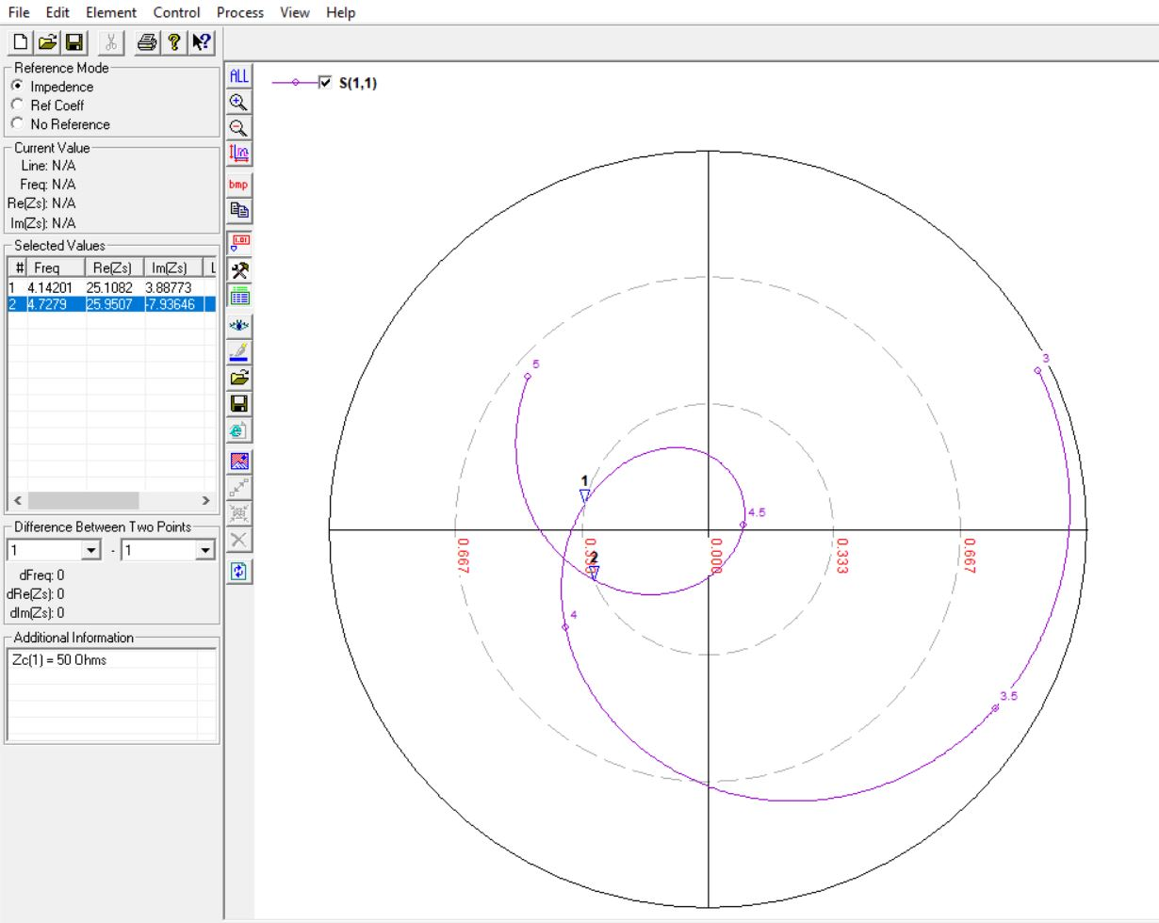

**4.3 GHz, 3 mm (0.05λ)**

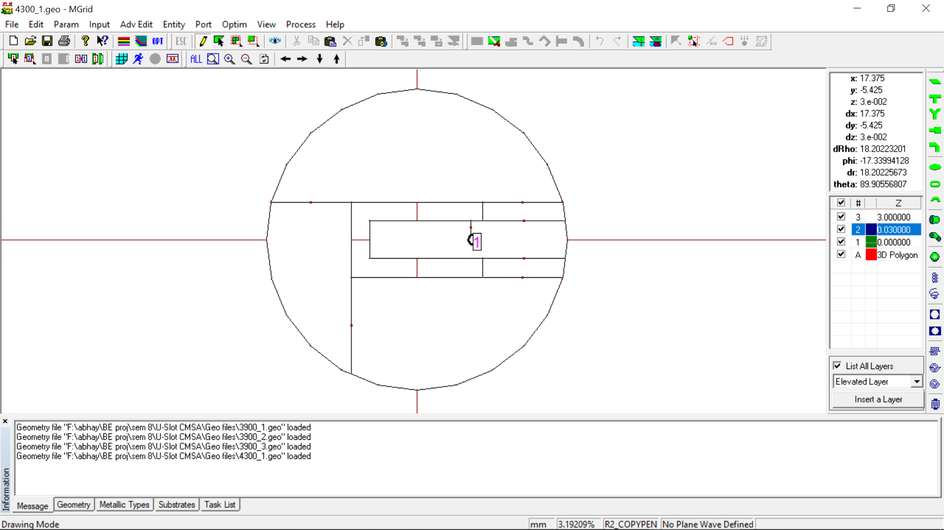

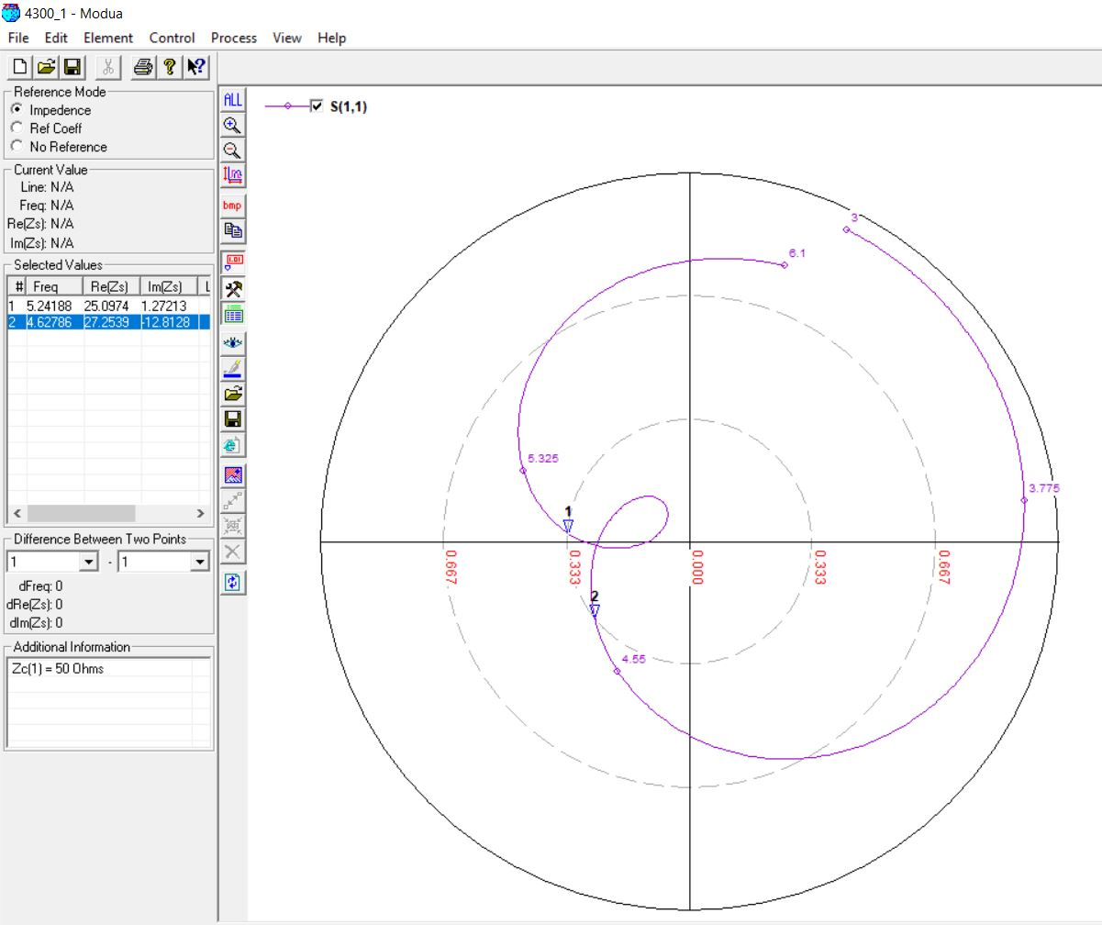

**4.3 GHz, 4 mm (0.06λ)**

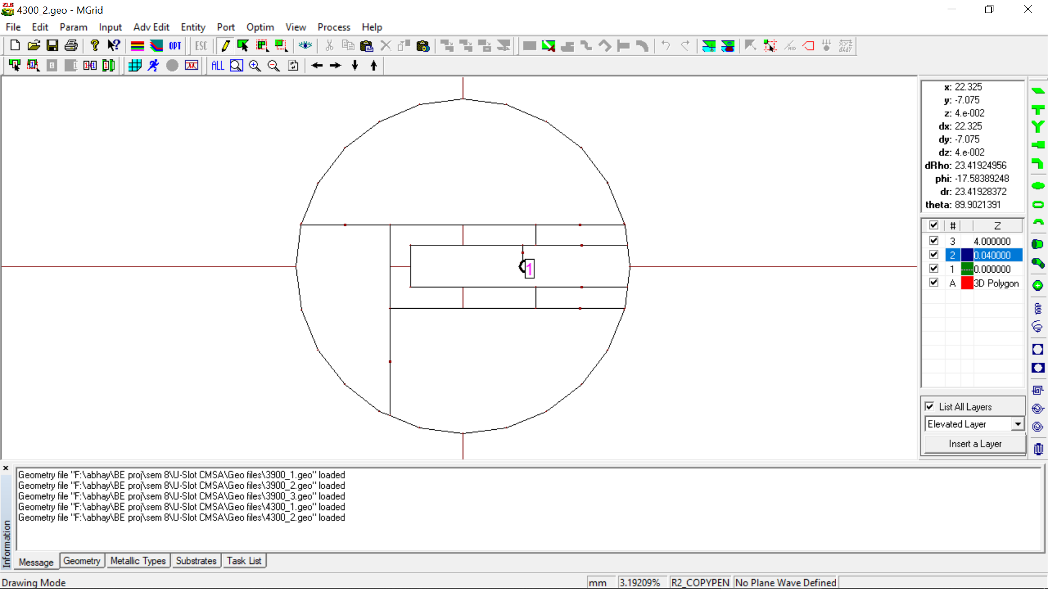

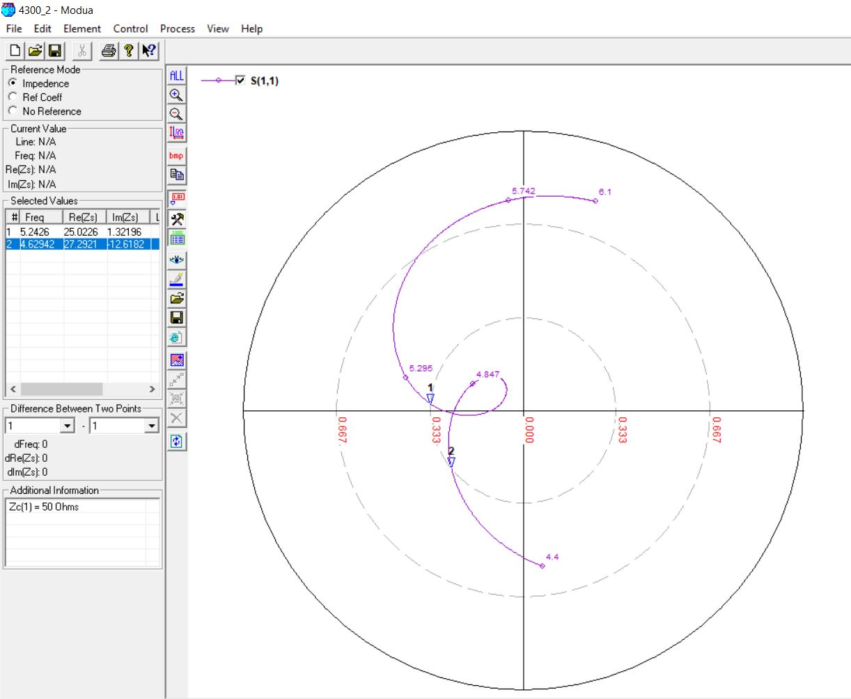

**4.3 GHz, 4 mm (0.07λ)**

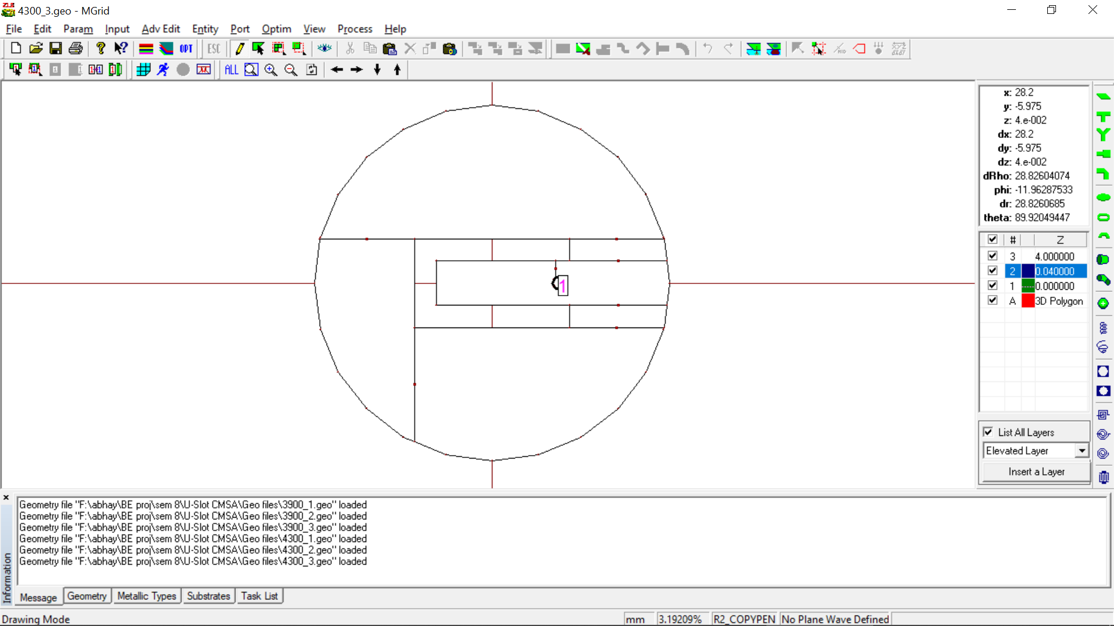

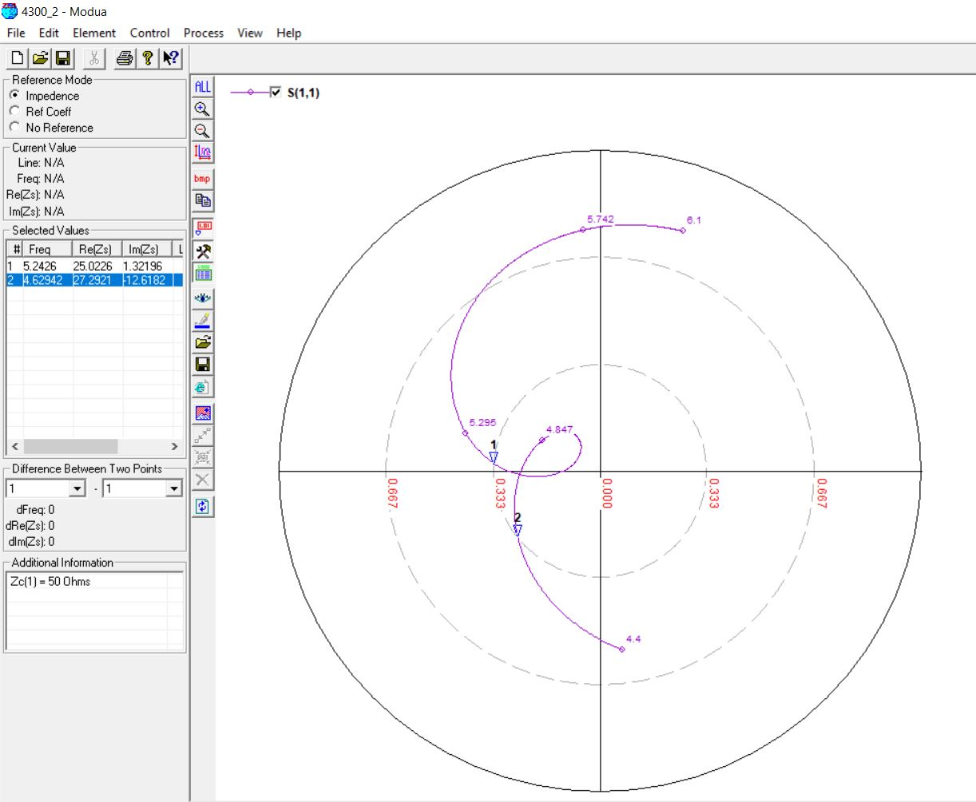

**4.9 GHz, 3 mm (0.05λ)**

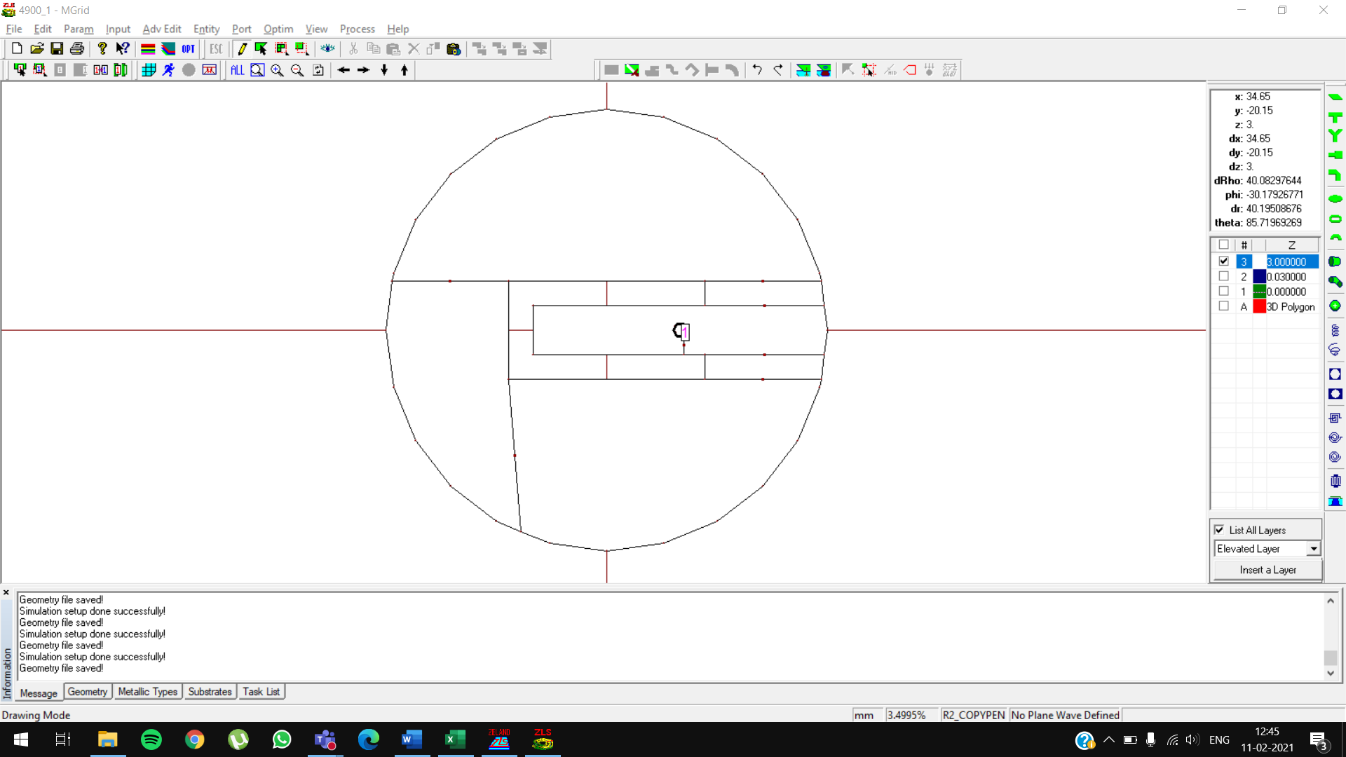

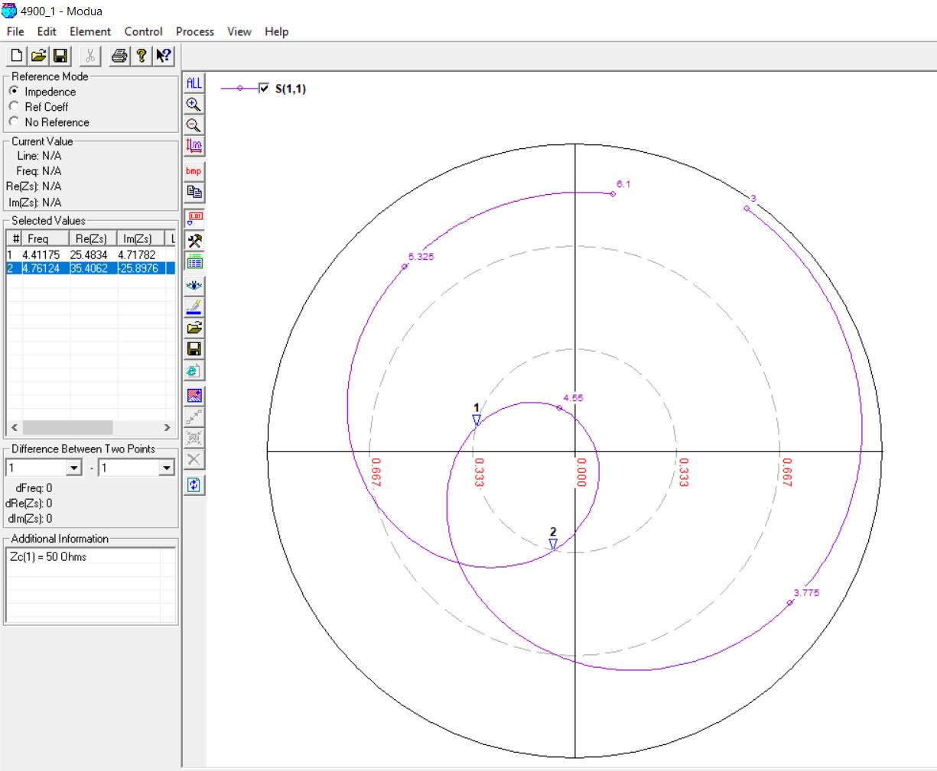

**4.9 GHz, 3 mm (0.06λ)**

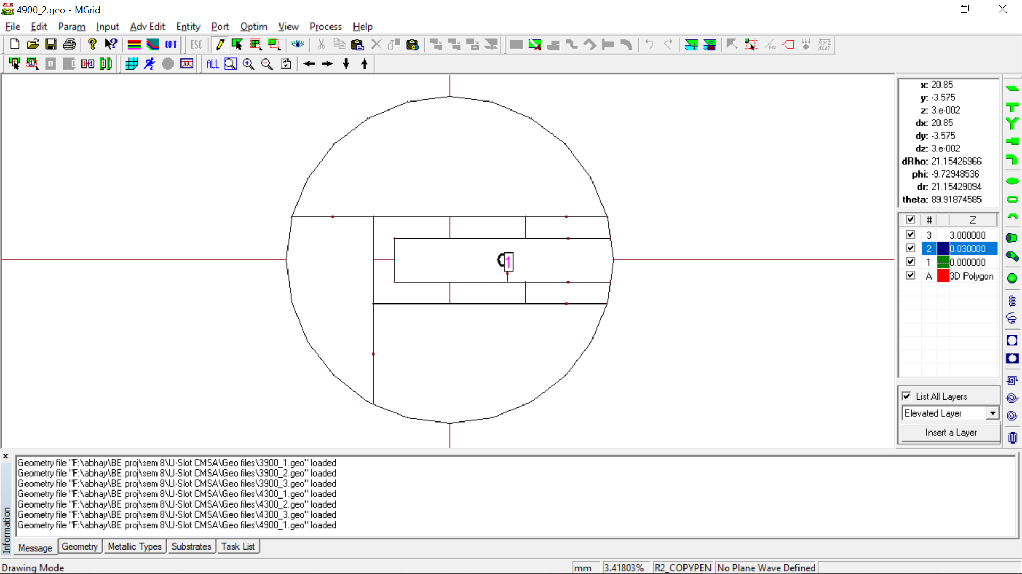

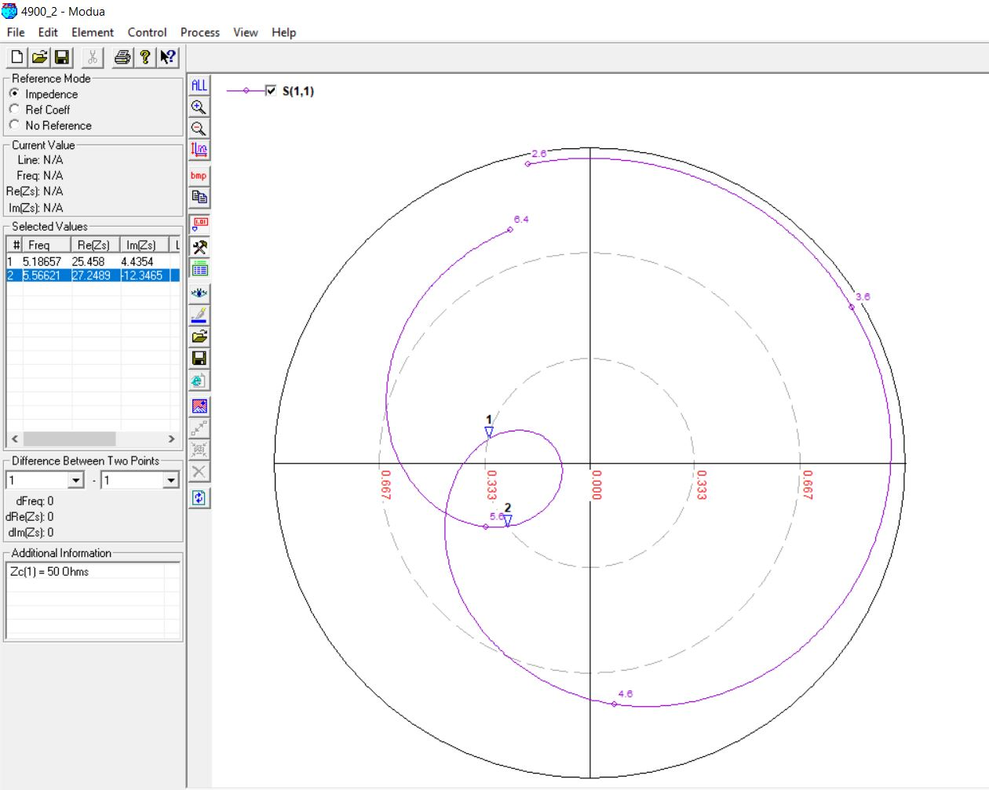

**4.9 GHz, 3 mm (0.07λ)**

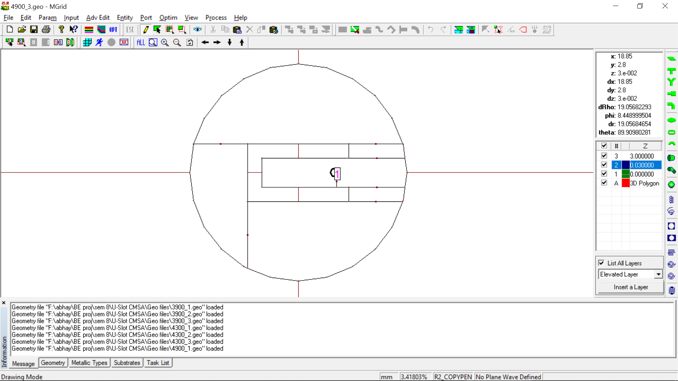

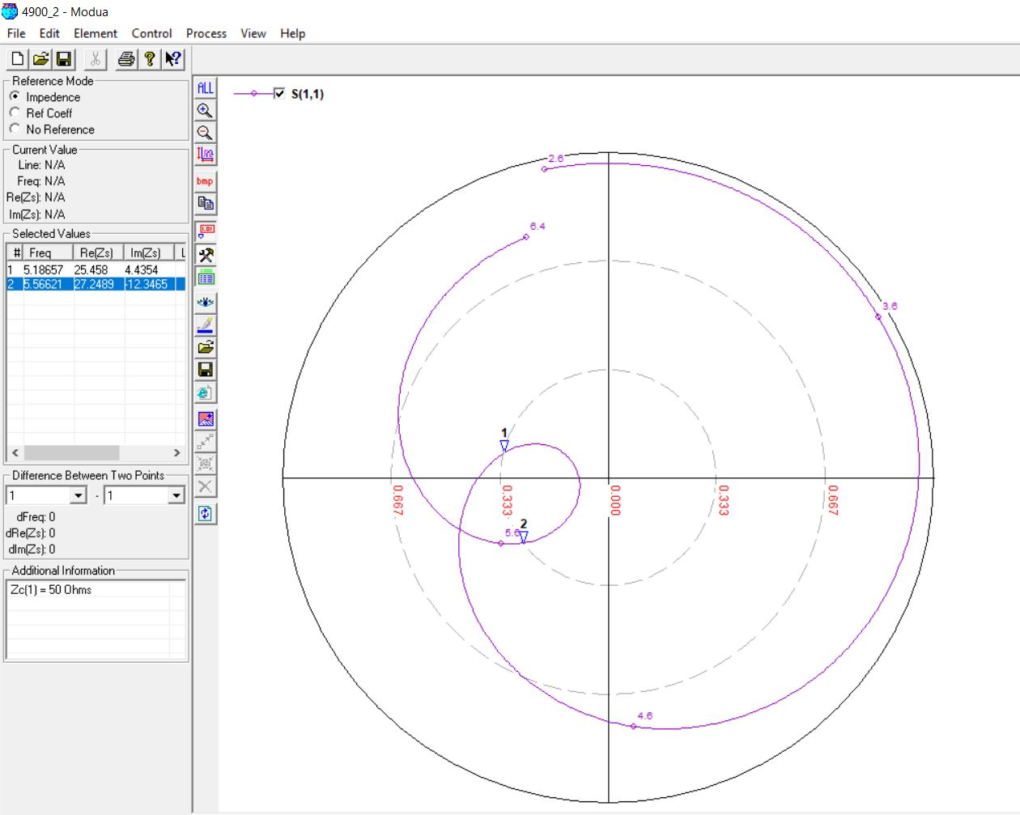

**5.1 GHz, 4 mm (0.05λ)**

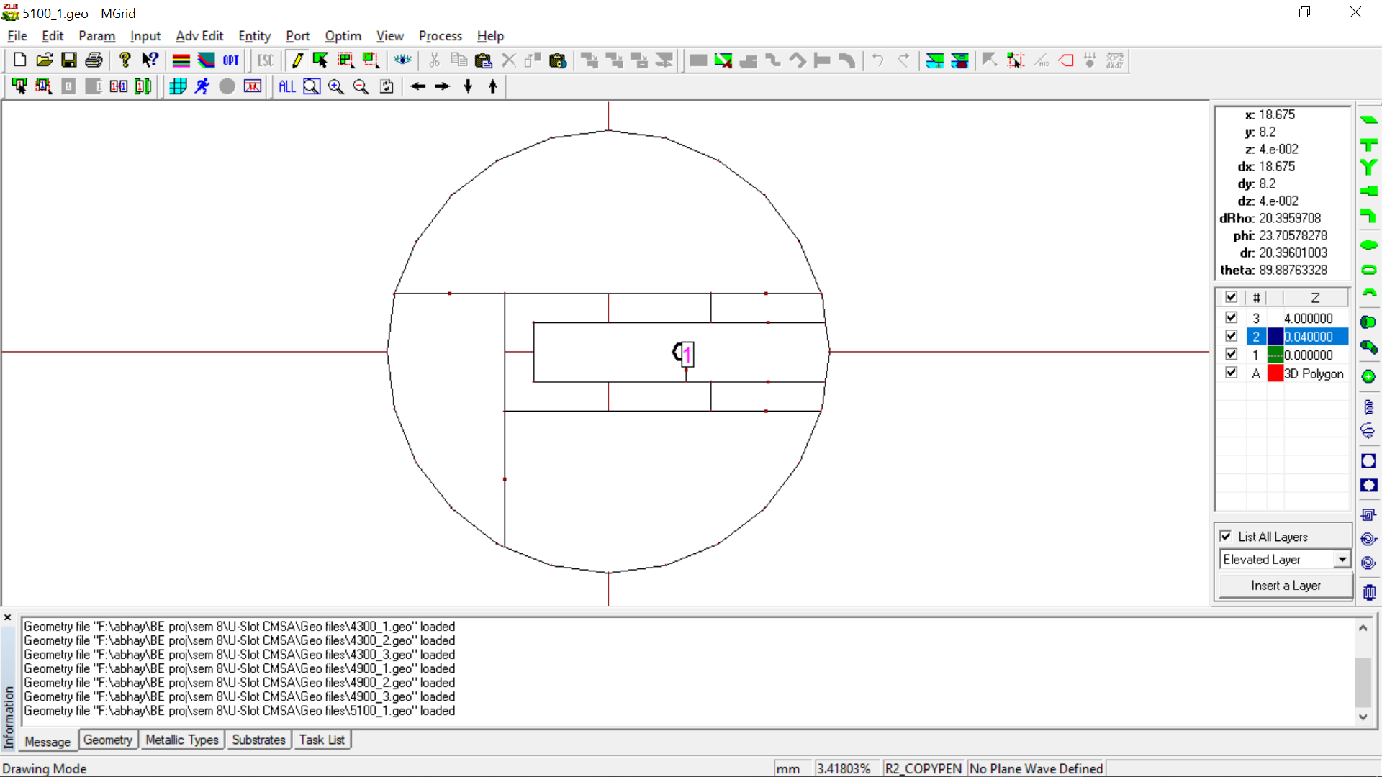

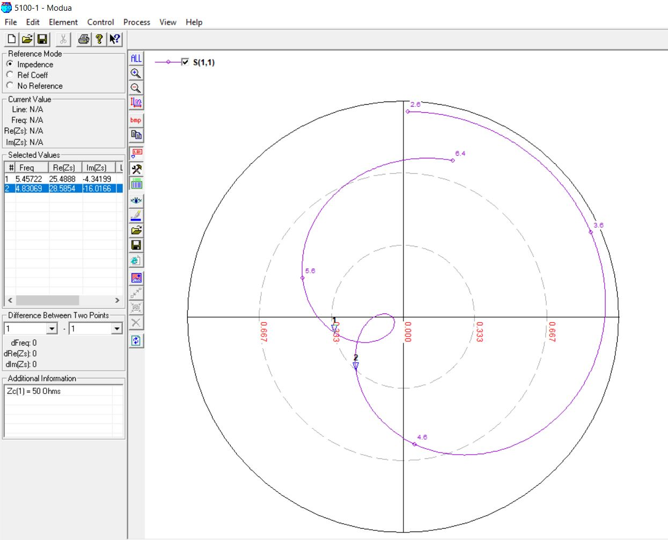

**5.1 GHz, 5 mm (0.06λ)**

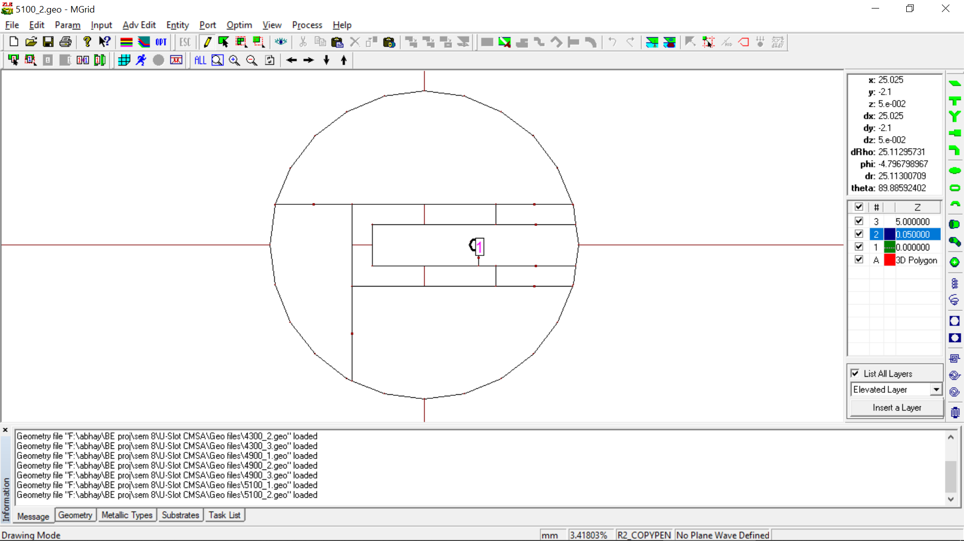

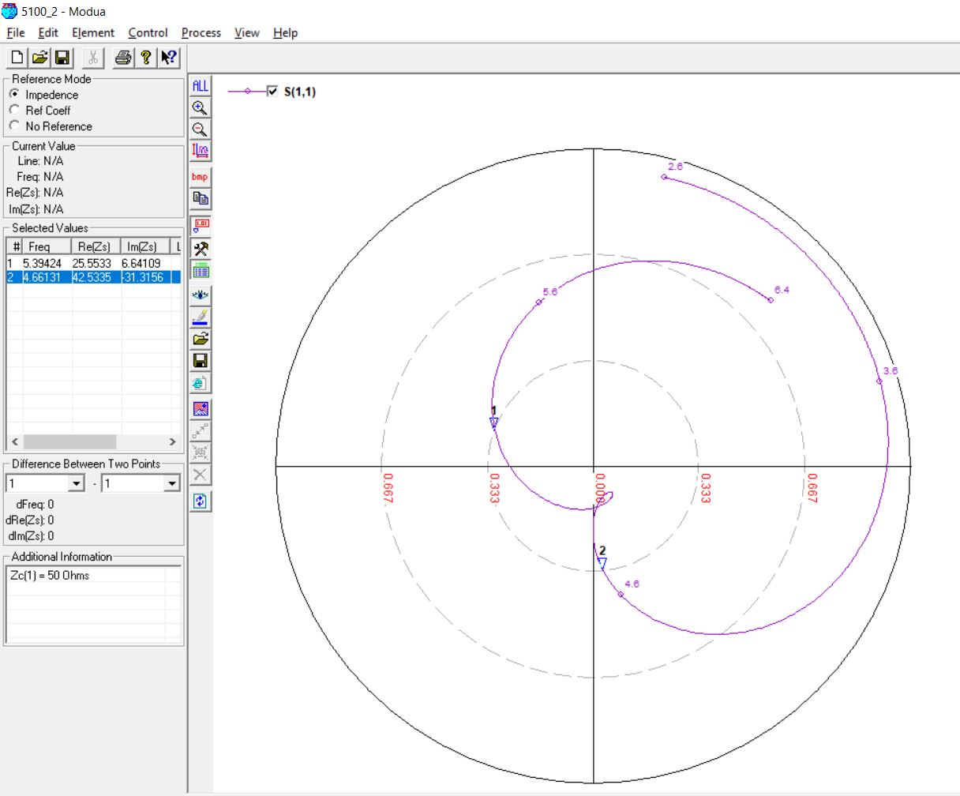

**5.1 GHz, 4 mm (0.07λ)**

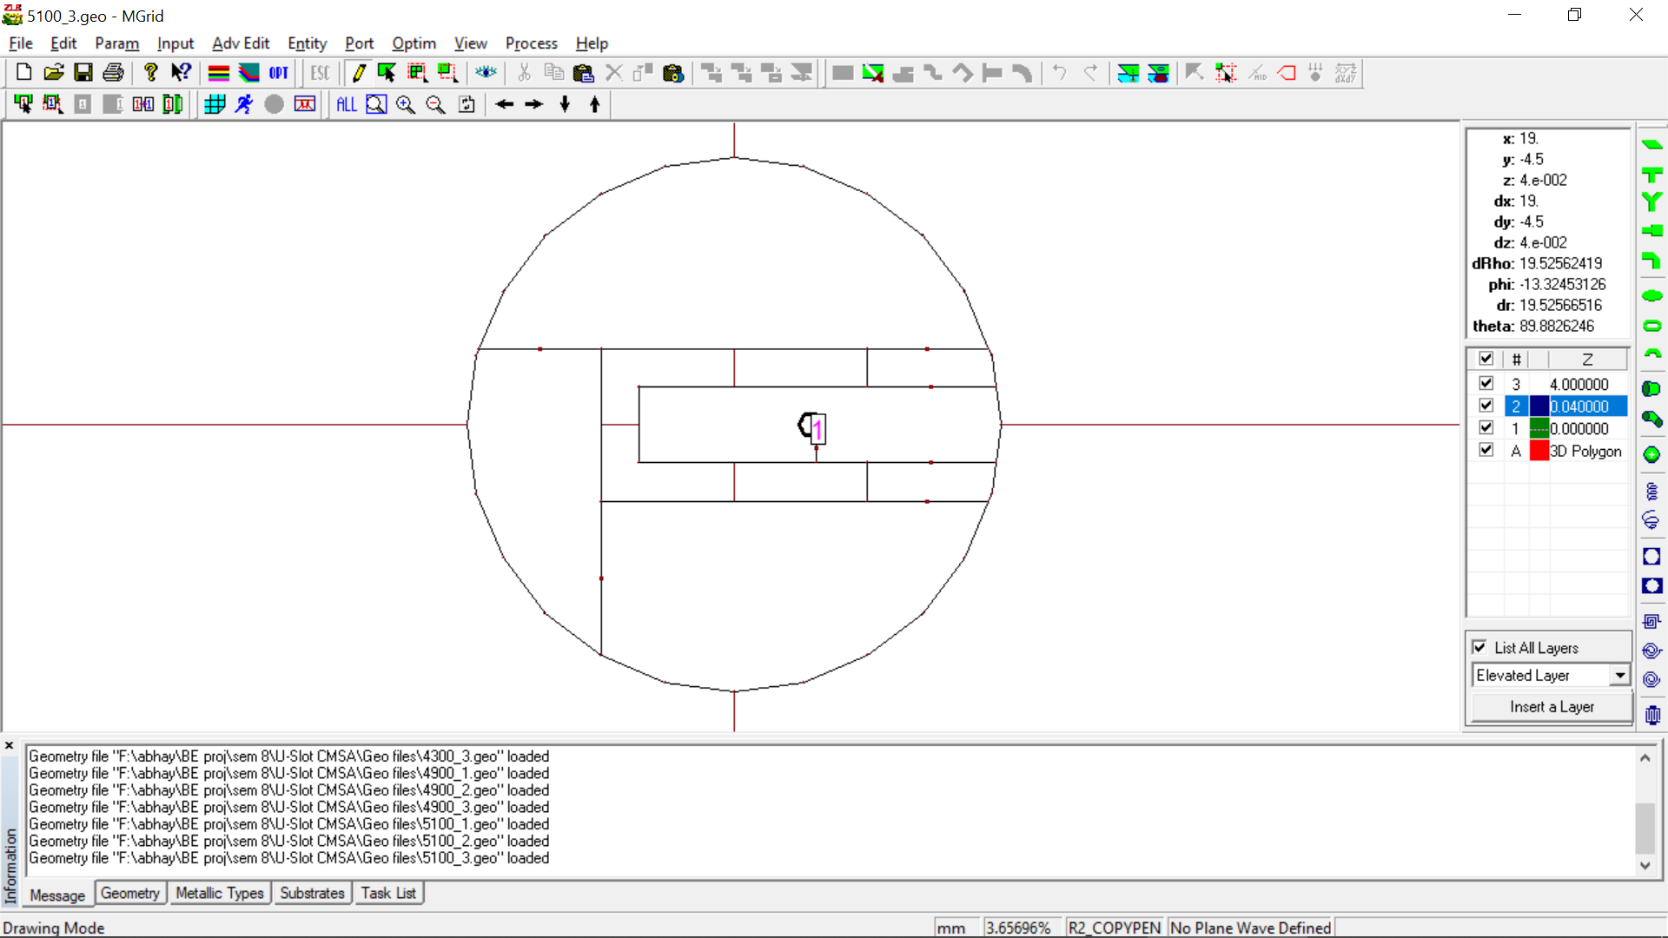

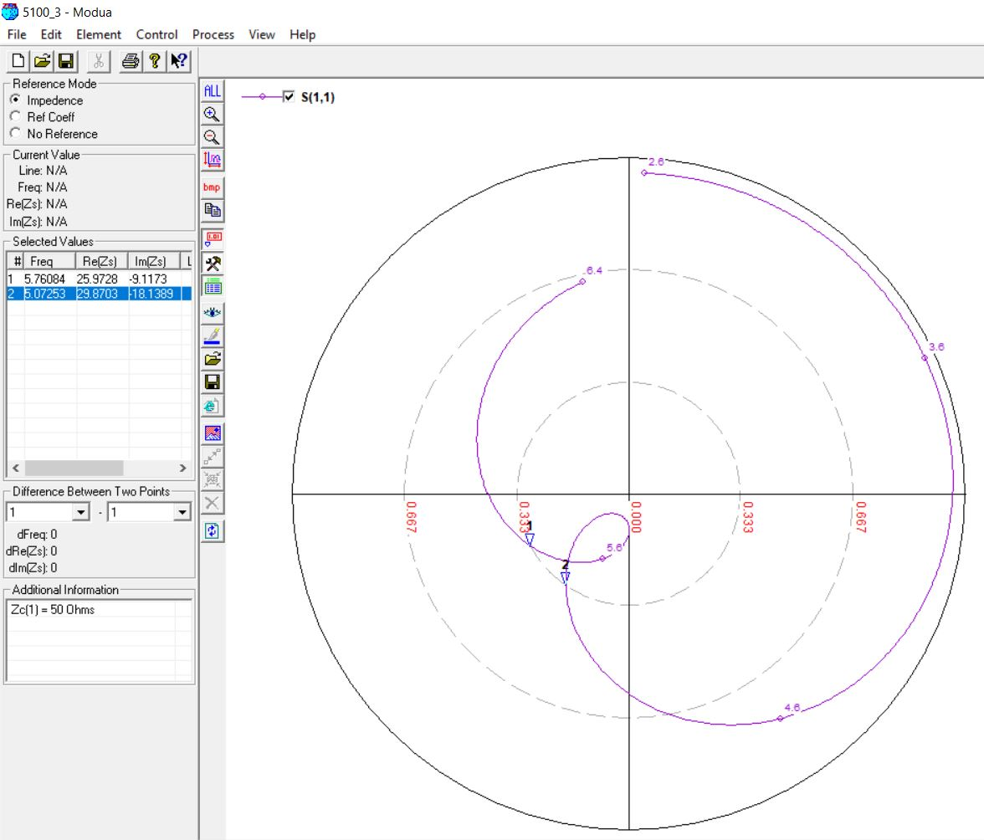

**5.5 GHz, 3 mm (0.05λ)**

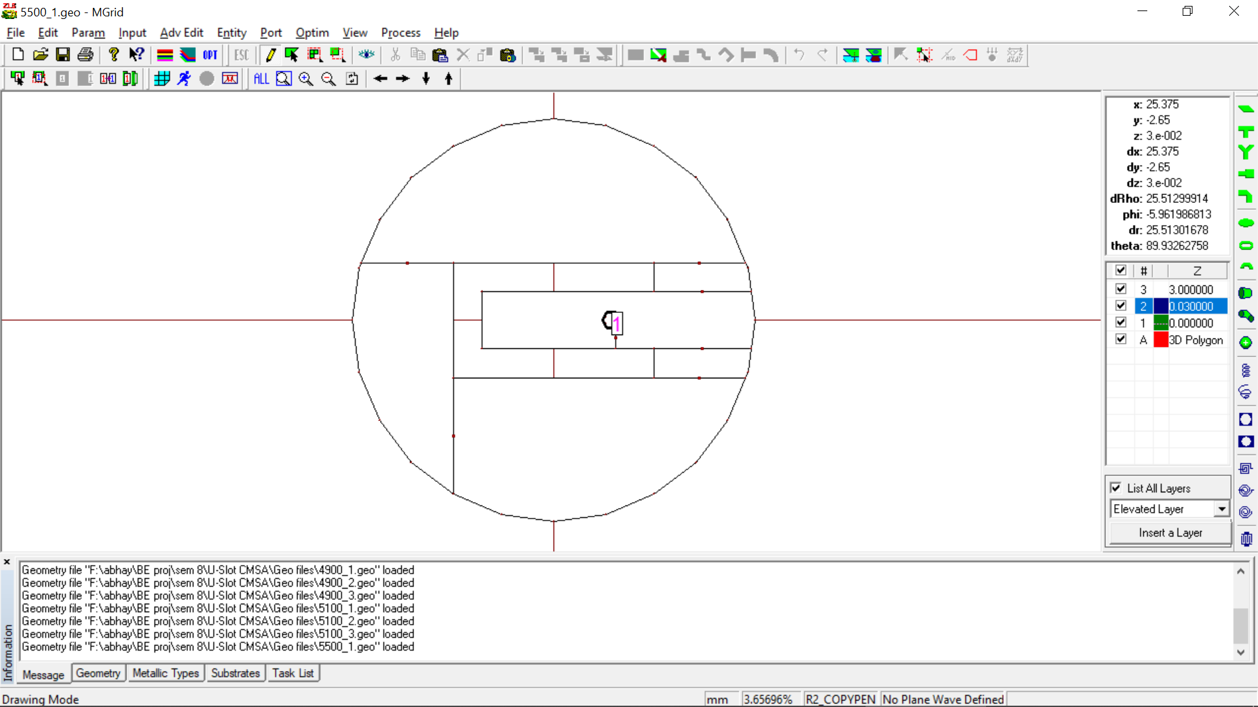

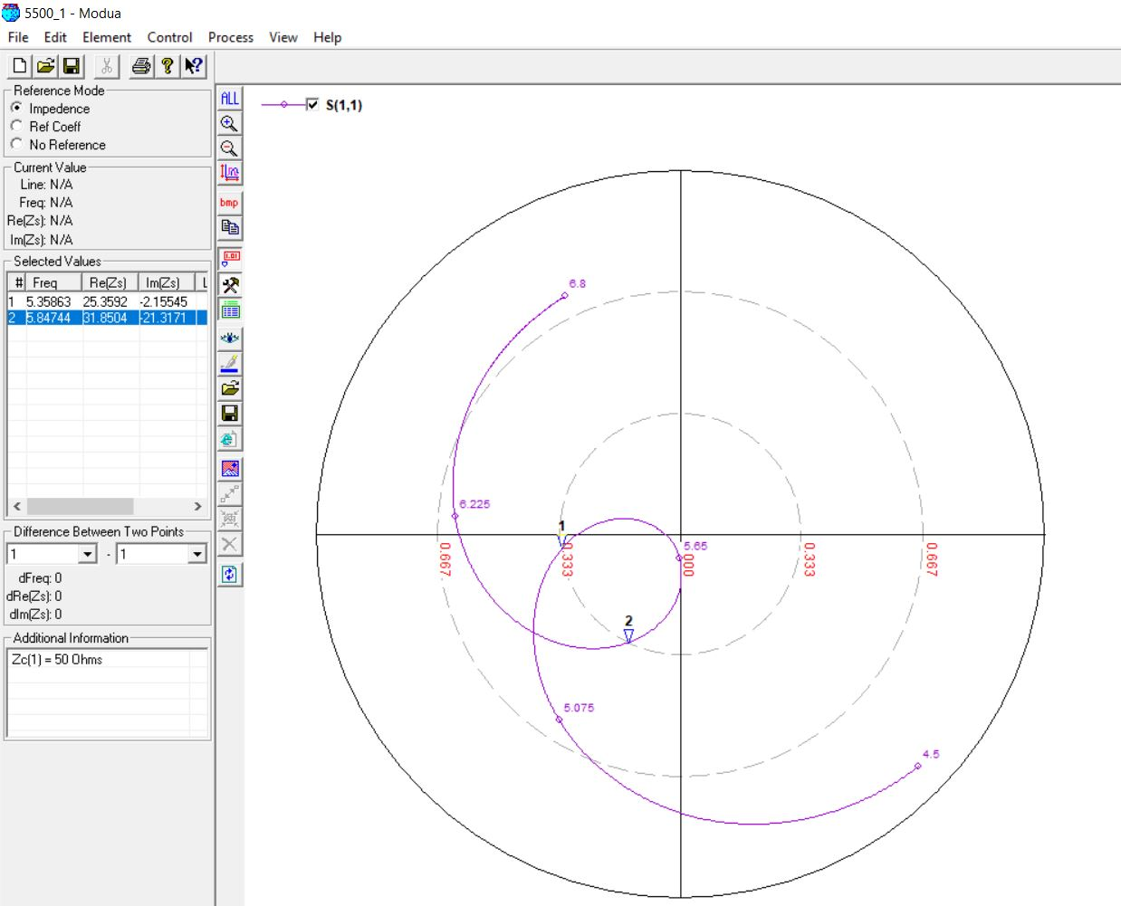

**5.5 GHz, 4 mm (0.06λ)**

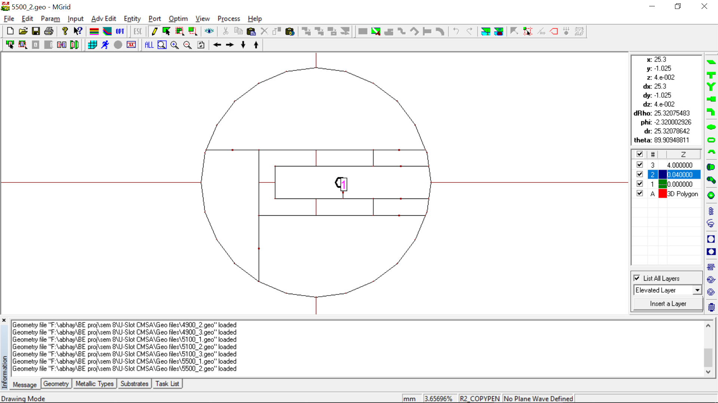

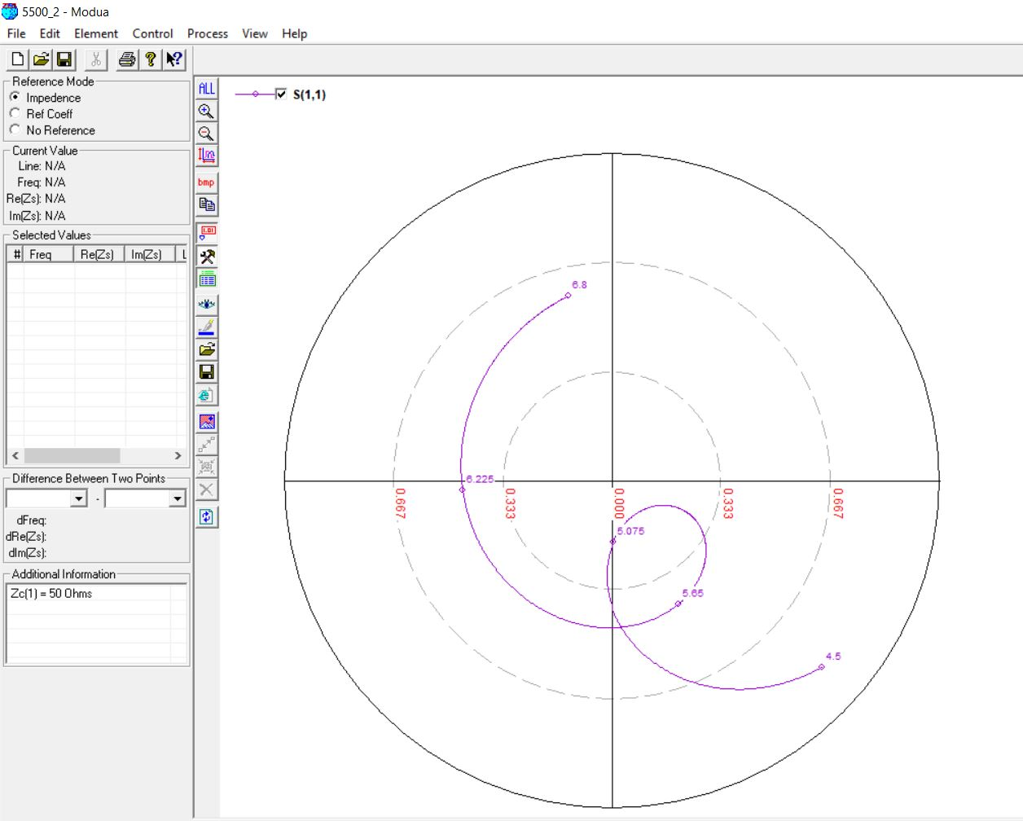

**5.5 GHz, 4 mm (0.06λ) [OPTIMIZED]**

**Original Feed Position: 3**

**Optimized Feed Position: 4**

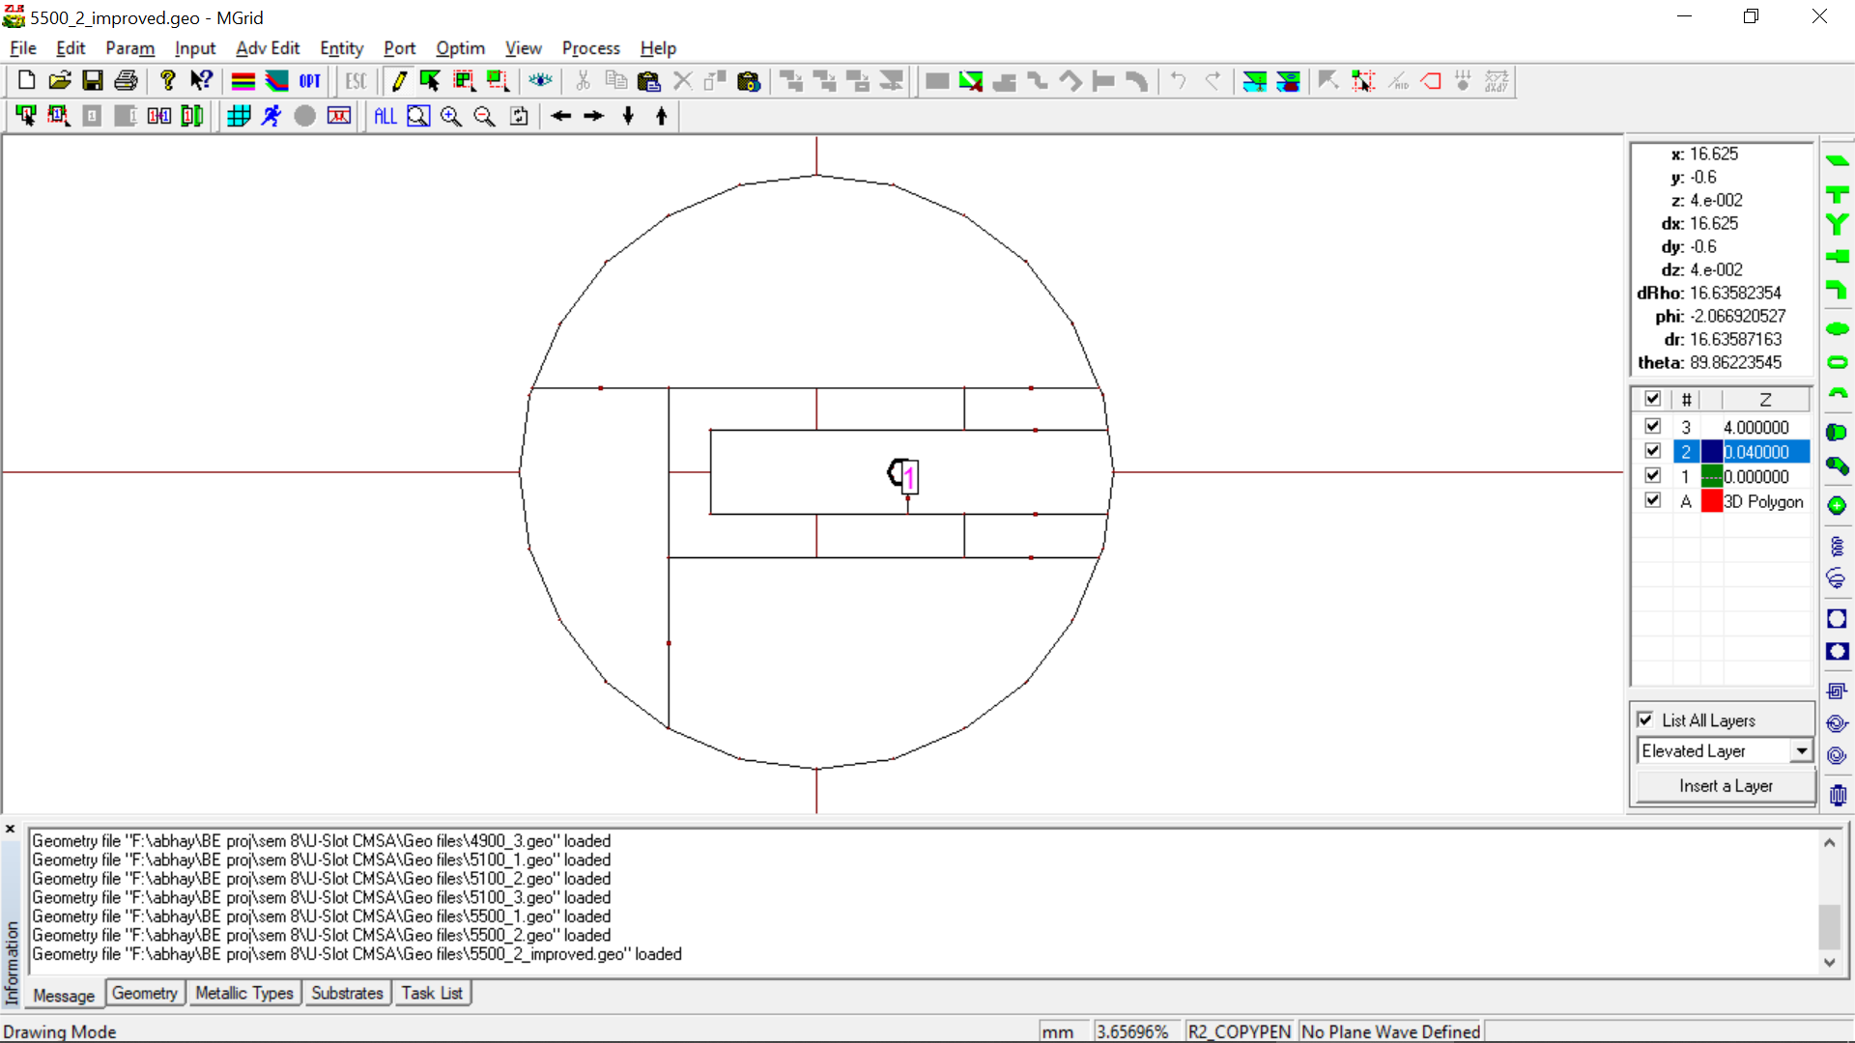

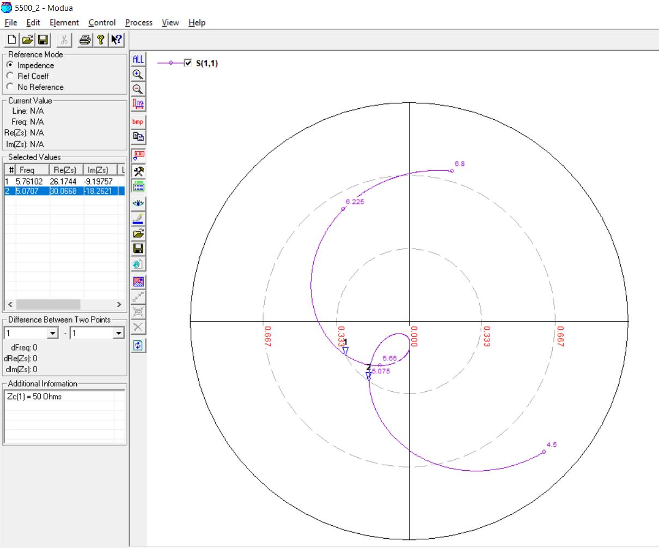

**5.5 GHz, 4 mm (0.07λ)**



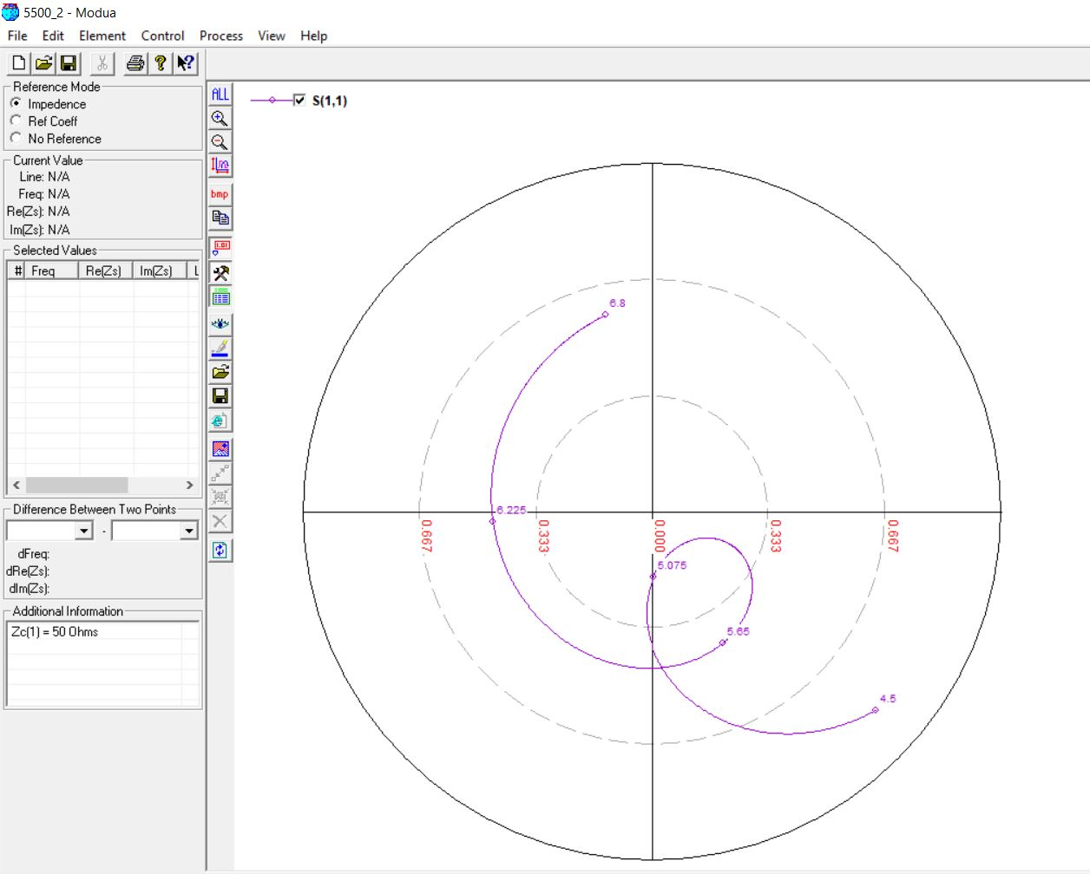

**5.5 GHz, 4 mm (0.07λ) [OPTIMIZED]**

**Original Feed Position: 3**

**Optimized Feed Position: 4**

